### *University of Pittsburgh*

### *School of Computing and Information*

**INFSCI 2711: Advanced Database Management System**

***Spring 2020***

**Final Project Report**



**Submitted By:**

|  |  |  |
| --- | --- | --- |
| **Name** | **Email Address** | **Student ID** |
| Aishwarya Jakka | [aij12@pitt.edu](mailto:aij12@pitt.edu) |  |
| Shruti Gupta | [shg104@pitt.edu](mailto:shg104@pitt.edu) | 4374956 |
| Piu Mallick | [pim16@pitt.edu](mailto:pim16@pitt.edu) | 4374215 |
| Reshma Sara Pothen | [rep83@pitt.edu](mailto:rep83@pitt.edu) |  |
| Soham Bhatnagar | [sob38@pitt.edu](mailto:sob38@pitt.edu) |  |
| Kenny Wu | [kew143@pitt.edu](mailto:kew143@pitt.edu) |  |
| Kwesi Randolph Aguillera | [kra40@pitt.edu](mailto:kra40@pitt.edu) |  |

**Online Retail Datawarehouse**

1. **Introduction**

**Need to be filled**

1. **Sub-Teams**

Teams responsible for exploring various areas in the project:

* **Coordination**
  + Aishwarya Jakka
* **Initial Data Cleaning**
  + Kwesi Randolph Aguillera
* **Further Data Cleaning**
  + Respective Teams
* **SQL-DB**
  + Shruti Gupta
  + Aishwarya Jakka
* **MongoDB**
  + Piu Mallick
  + Reshma Sara Pothen
* **Neo4j**
  + Soham Bhatnagar
  + Kenny Wu
  + Kwesi Randolph Aguillera
  + Aishwarya Jakka
* **Front-end & Back-end integration**
  + Kenny Wu
  + Kwesi Randolph Aguillera
* **Documentation**
  + Piu Mallick
  + Reshma Sara Pothen
  + Shruti Gupta

1. **Dataset Description**

This [**Online Retail II**](https://archive.ics.uci.edu/ml/datasets/Online+Retail+II) data set (the original dataset is a **excel file**) contains all the transactions occurring for a **UK-based** and registered, non-store online retail between **01/12/2009 (1st Dec 2009)** and **09/12/2011 (9th Dec 2011)**. The company mainly sells **unique all-occasion giftware**. Many customers of the company are wholesalers.

* 1. **Attribute Information**

The dataset has the following attributes:

* **InvoiceNo**: Invoice number. Nominal. A 6-digit integral number uniquely assigned to each transaction. If this code starts with the letter 'c', it indicates a cancellation.
* **StockCode**: Product (item) code. Nominal. A 5-digit integral number uniquely assigned to each distinct product.
* **Description**: Product (item) name. Nominal.
* **Quantity**: The quantities of each product (item) per transaction. Numeric.
* **InvoiceDate**: Invoice date and time. Numeric. The day and time when a transaction was generated.
* **UnitPrice**: Unit price. Numeric. Product price per unit in sterling (Â£).
* **CustomerID**: Customer number. Nominal. A 5-digit integral number uniquely assigned to each customer.
* **Country**: Country name. Nominal. The name of the country where a customer resides.
  1. **Github Link**

The Github link for the project repository: [Click here](https://github.com/Aishwaryajakka/infsci2711_finalproject)

1. **Assumptions**

* An item can have multiple descriptions for the same StockCode.
* We are assuming that a top product is the product that is most purchased by the customer.
* We are assuming that the currency is the same across all the countries.

1. **Initial Data-Cleaning**

Following are the initial set of steps to clean the data:

* Removed records with blank CustomerIDs.
* Removed records weird StockCodes.
* Corrected Description where possible.
* Removed records where Description cannot be corrected.
* Removed zero Price items.
* Removed “Unspecified” country records.
* Changed Negative quantity records to positive quantity values.
* Separate Datetime into Date and Time columns.
* Calculate SubTotal for each record.

Following are the column stats for the year **2009-2010**:

* No. of records before cleaning: 525461
* No. of records after cleaning: 413084
* InvoiceNo Range: 489437 – 528618 / C489449 – C538168
* StockCode Range: 10002 – 90208 / 10123C – 90214Z & SP1002
* Quantity Range: 1 – 19,152
* Date Range: Dec 2009 – Dec 2010
* Time Range: 7:01 AM – 9:52 PM
* UnitPrice Range: $0.08 - $295.00
* CustomerID Range: 12346 – 18287
* No. of Countries: 40
* SubTotal Range: $0.06 - $15,818.40

Following are the column stats for the year **2010-2011**:

* No. of records before cleaning: 541910
* No. of records after cleaning: 300766
* InvoiceNo Range: 536365 – 564272 / C536383 – C564276
* StockCode Range: 10002 – 90208 / 10123C – 90214Z
* Quantity Range: 1 – 80,995
* Date Range: Dec 2010 – Dec 2001
* Time Range: 7:35 AM – 8:38 PM
* UnitPrice Range: $0.08 - $649.50
* CustomerID Range: 12347 – 18287
* No. of Countries: 40
* SubTotal Range: $0.06 - $168,469.60

The **initial data cleaning** was done manually in **Microsoft Excel**.

Post initial data cleaning, some extra cleaning was done in order to meet various database needs, which will be discussed later in this report.

1. **Possible Aggregation Queries**

Following are the probable statistical and aggregation queries that the owner/manager of the store may want to view in order to get the growth report of their store:

1. What time of the day (which hour of the day) is the sale maximum per country?
2. What is the annual TotalSales per product?
3. What is the top product per year?
4. What is the top product per country?
5. Which item is sold below a certain threshold value? Or, what are the under-performed products based on the average sales last year (the year denotes either 2009 or 2010)?
6. Which customer spends the most (per country/overall)?
7. What is the best-selling month per country? (Given the year range, 2009-2011)
8. What is the best-selling product per month? (Given the year range, 2009-2011)
9. What is the change in TotalSales per country per year (Trend of Sales)?
10. What is the average spending of a customer per country? (TotalSales/Number of customers)
11. What is the frequently purchased item per customer?
12. **STAR Schema: Design**

Based on the queries (which we want to ask the database) stated above, we have designed the **DIMENSIONS** and **MEASURES**, which we popularly call as a **STAR schema**. Hence, first comes the aggregate queries, and based on the queries, we would like to build our aggregated database.

**DIMENSIONS**: Customer, Stock, Time

**MEASURES**: Quantity, Sales

**STAR SCHEMA:**

Hence, the **tables** (with all the **attributes**) we would be considering are as follows:

* **FACT** (*CustomerID, Year, Month, Day, Hour, Minute, StockCode, Quantity, TotalSales*)
* **CUSTOMER_DIM** (*CustomerID, Country*)
* **STOCK_DIM** (*StockCode, Description, MaxUnitPrice*)
* **TIME_DIM** (*Year, Month, Day, Hour, Minute*)

  However, the above table definitions may change depending on the databases we would be using.

1. **Databases**

We have chosen 3 databases, namely **SQL, MongoDB** and **Neo4j** for building our **Online Retail Datawarehouse**. We would be integrating each of the databases with front-end, which we will discuss later in the document.

**Please note**: All the data-warehouse design, implementation and execution are done on local instance(s). The project is not hosted on Cloud system.

* 1. **SQL DB**
     1. **Creating the ODB (Operational Database)**
* **Extra data-cleaning for SQL DB:**

Steps followed to clean the **Cleaned2009-2010.xlsx** and **Cleaned 2010-2011.xlsx.** (actual data files) from the data folder:

* Renamed column "Customer ID" to Customer_ID
* Changed format of the InvoiceDate from MM/DD/YY to YYYY-MM-DD
* Changed format of the InvoiceTime from HH:MM AM/PM to HH:MM:SS (24 hour format)
* Changed format of the SubTotal to remove the "," formatting of numeric value.
* Saved the file as <filename>.xlsx
* Then saved file as <filename>.csv
* The above steps are repeated for the other file (2010-2011) as well.
  + 1. **Steps followed to import the data in phpMyAdmin:**
* Created SQL insert script
* Inserted the script in batches of 25000 as this was the limit for insertion
* The ODB creation process took a significant amount of time as import functionality didn’t work with the csv.
* Tried MySQL workbench to insert the script. All insertion done in one go
  + 1. **Creating the ADB (Analytical Database)**

**• Steps followed to create the ADB, relevant tables and furnish data**

* Created a new database ‘online_retail_adb’ .
* Once the Analytical Database was created, we were ready to create the table specified in the schema – specifically, 3 dimension tables – ‘customerdim’, ‘stockdim’ and ‘timedim’ along with the ‘fact’ table.
* For each of these tables, we used the insert scripts to move data from the ODB to the relevant ADB table.
* For the FACT table, we extracted the relevant fields from the ODB. Note that even though the ODB had ‘Sub Total’ as a field, it was renamed ‘TotalSales’ in the FACT table.
* For the customerdim table:

The customerdim table required the ‘Customer_ID’ and ‘Country’ fields. This was done using a ‘groupby’ operator. To remove duplicates in CustomerID, operator was used. Finally, used insertion script to insert data into customerdim.

* For the stockdim table:

The stockdim table required the ‘StockCode’, ‘Description’ and ‘Unit_Price’ fields.

There was different unit price for single StockCode, so we took the maximum unit price.

Insertion script was used to insert data into stockdim table

* For the timedim table:

The timedim table required the ‘Day’, ‘Month’, ‘Year’, ‘Hour’ and ‘Minute’ fields. Distinct rows were inserted from ODB

* **Challenge Faced:**

Since the database is too big, it took time to insert data.

* + 1. **Aggregation Queries**
* **What time of the day is the sale maximum per country? (Query 1)**

This query required three join, making the query very expensive. It took around 5 minutes to run.

In order to improve the run time, we created a materialized view named ‘mview_sum_sale_country’. Using the materialized view, run time decreased drastically.

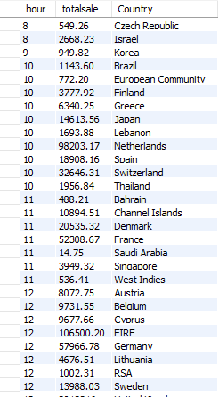

* **Annual total sales of per product? (Query 2)**

This query required three join, making the query very expensive. It took around 7 minutes to run

In order to improve the run time, we created a materialized view named ‘mview_totalsale_product’. Using the materialized view, run time decreased drastically.

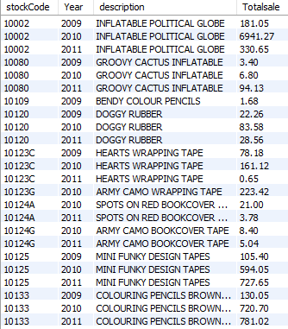

* **Top product per year? (Query 3)**

This query required three join, making the query very expensive. It took around 5 minutes to run

In order to improve the run time, we created a materialized view named ‘mview_totalsale_product’. Using the materialized view, run time decreased drastically.

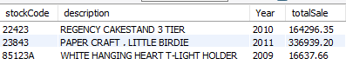

* **Top product per country? (Query 4)**

This query required three join, making the query very expensive. It took around 5 minutes to run

In order to improve the run time, we created a materialized view named ‘mview_totalsale_product’.Using the materialized view, run time decreased drastically.

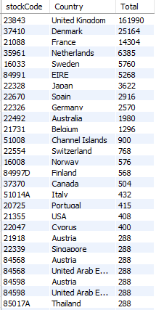

* **Which item is sold below the threshold value?** **? Or, what are the under-performed products based on the average sales last year (the year denotes either 2009 or 2010)? (Query 5)**

For this query, threshold for a stock each year is devised by the average sale in the previous year. So, for any stock if there is sales record available for only one year, it is not considered. Also, if there are no record available for two consecutive years, the next available year is considered. For example, if for a stock we have data for the year of 2017 but no record for 2018 and then we have record for 2019, the records for 2019 is compared against 2017.

This query required three join, making the query very expensive. It took around 7 minutes to run

In order to improve the run time, we created a materialized view named ‘mview_quantity_product_year’. Using the materialized view, run time decreased drastically.

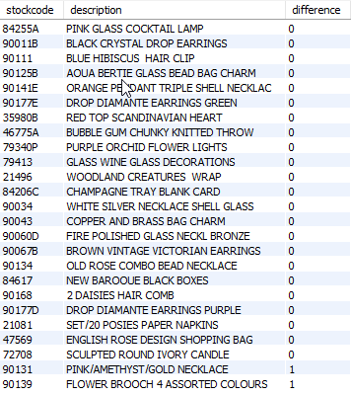

* **Which customer spends the most per country? (query 6)**

This query required three join, making the query very expensive. It took around 5 minutes to run

In order to improve the run time, we created a materialized view named ‘mview_customer_total_country’. Using the materialized view, run time decreased drastically.

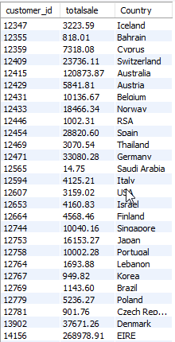

* **Best-selling month (per country) [2009-2011] (Query 7)**

This query required three join, making the query very expensive. It took around 5 minutes to run

In order to improve the run time, we created a materialized view named ‘mview_sale_month’. Using the materialized view, run time decreased drastically.

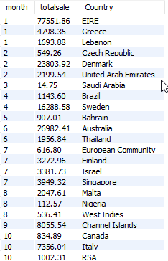

* **Best-selling product per month [2009-2011] (query 8)**

This query required three join, making the query very expensive. It took around 5 minutes to run

In order to improve the run time, we created a materialized view named ‘mview_quantity_product’. Using the materialized view, run time decreased drastically.

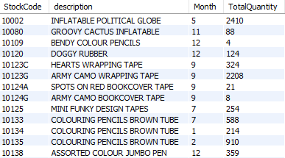

* **What is the change in total sales per country per year (trend of sales)?** **(Query 9)**

This query required three join, making the query very expensive. It took around 5 minutes to run

In order to improve the run time, we created a materialized view named ‘mview_yearsale_country’. Using the materialized view, run time decreased drastically.

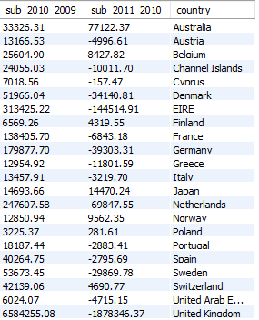

* **Average spending of a customer in that country (Query 10)**

This query required both ‘CustomerID’ and ‘Country’ from the ‘Customerdim’ table. The data was grouped by ‘Country’ and the average of ‘TotalSales’ was calculated. The results were then sorted and displayed.

This query required three join, making the query very expensive. It took around 5 minutes to run

In order to improve the run time, we created a materialized view named ‘mview_customer_total_country’. Using the materialized view, run time decreased drastically.

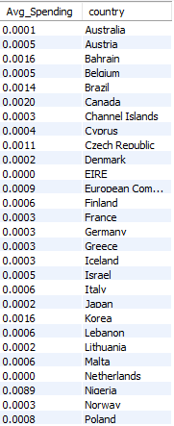

* **Frequently purchased item per customer? (Query 11)**

This query used same table, so materialized view was not required.

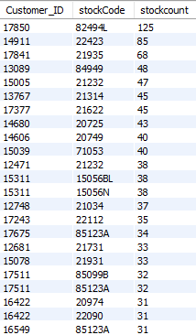

* + 1. **Materialized queries:**

For materialized queries, we first created the relevant table, i.e. table used for optimizing the query, and then inserted the data into the table for further usage.

* ‘mview_sum_sale_country’: This materialized query was used to get the TotalSale per Hour per Country. This query further used in query for finding ‘what time of the day is the sale maximum per country’
* ‘mview_totalsale_product’ : This materialized query was used to get the Totalsale per stockCode per Year and the respective description of stockcode.
* mview_quantity_product_year’ : This materialized query was used to get the TotalQuantity per stockCode per Year with respective description of Stockcode
* mview_customer_total_country’: This materialized query was used to get the TotalSale per Customer_ID per Country.
* mview_sale_month’ : This materialized query was used to get the TotalSale per month per country
* mview_quantity_product’ : This materialized query was used to get the TotalQuantity per stockCode per Month with description based on StockCode
* mview_yearsale_country’ : This materialized query was used to get the TotalSale per Year per Country
* mview_product_country : This materialized query was used to get the TotalQuantity per Country per Stockcode
  + 1. Advantages and disadvantages of MySql:
* Advantages are that all the queries run in Mysql. It is possible to run every type of query by applying multiple joins
* Disadvantage is it takes a lot of time to run. With multiple joins, it becomes expensive
  1. **MongoDB**
     1. **Creating the ODB (Operational Database)**
* **Extra data-cleaning for MongoDB:**

Steps followed to clean the **Cleaned2009-2010.xlsx** and **Cleaned 2010-2011.xlsx.** (actual data files) from the **data** folder:

* Changed the **file type** to **csv**.
* Loaded the **csv files** to **Jupyter Notebook** (**Python**) and converted them to dataframes.
* Concatenated two dataframes using the ‘**append’** function.
* The attribute ‘**Customer ID**’ is renames to ‘**CustomerID**’.
* The attributes ‘**InvoiveDate**’ and ‘**InvoiceTime**’ are then concatenated and renamed to ‘**InvoiceDateTime**’. Later, they are split to **Year** (**YYYY**), **Month** (**MM**), **Day** (**DD**), **Hour** (**HH**) and **Minute** (**MM**).
* The dataframe is then exported to the data folder as ‘**Online_Retail_DB.csv**’.
* **Steps followed to import the csv file to MongoDB:**
* Go to the **terminal** and login to **MongoDB** (by typing ‘**mongo**’ to stay in the same terminal or ‘**mongod**’ to switch to a new terminal).

**Pre-requisite**: Prior installation of MongoDB in the system and the **mongodb service** to be running.

* Switch to or create a new database – ‘**odb**’ in MongoDB with the help of the following command in the terminal:
* In a separate terminal, navigate to the path where the cleaned data file is present. The **MongoDB import command** is executed outside the mongo shell - in a normal terminal, with the help of the following command.
* At the end of this process, the relevant documents were successfully inserted. This is shown below.

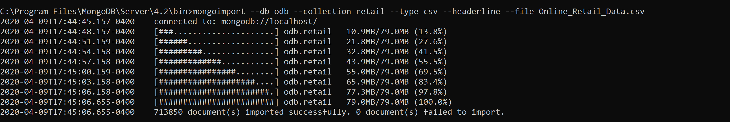

* + 1. **Creating the ADB (Analytical Database)**

**•** **Steps followed to create the ADB, relevant tables and furnish data**

* Created a new database ‘**adb**’ in **MongoDB**.

Specified ‘**adb**’ as the current database using the following command: **use adb**

* Once the **Analytical Database** was created, we were ready to create the table specified in the schema – specifically, **3-dimension** tables (called **collections** in **MongoDB**) - **customer_dim**, **stock_dim** and **time_dim** along with the **FACT** table.
* For each of these collections, we used the **.getSiblingDB** function to move data from the **ODB** to the relevant **ADB** table.
* For the **FACT** collection:

We extracted the relevant fields from the **ODB**. Note that even though the ODB had ‘**SubTotal**’ as a field, it was renamed ‘**TotalSales**’ in the **FACT** table. The ‘**forEach**’ function is used to loop through the retail collection for all records.

* For the **customer_dim** collection:

The **customer_dim** collection required the ‘**CustomerID**’ and ‘**Country**’ fields. This was done using a ‘**$group**’ operator. To remove duplicates in CustomerID, the ‘**$match**’ operator was used. Finally, as with the **FACT** table data insertion, ‘**forEach**’ was used to loop through the retail collection in the **ODB** and insert every record.

* For the **stock_dim** collection:

The **stock_dim** collection required the ‘**StockCode**’, ‘**Description**’ and ‘**MaxUnitPrice**’ fields. Initially, an index was created for ‘**StockCode**’ to allow faster query execution. This was followed by an aggregation query on the retail collection. Note that **Price** was changed to **MaxUnitPrice**.

* For the **time_dim** collection:

The **time_dim** collection necessitated a two-step approach to insertion. Initially, the data for the ‘**Day**’, ‘**Month**’, ‘**Year**’, ‘**Hour**’ and ‘**Minute**’ fields were fetched, using the **forEach** function, from the retail collection and inserted into a temporary table ‘**time_dim_temp**’. Once done, the data was aggregated into ‘**Day**’, ‘**Month**’, ‘**Year**’, ‘**Hour**’ and ‘**Minute**’ into the final ‘**time_dim**’ collection.

At the end of this process, all four collections were populated. The relevant statistics are displayed below.

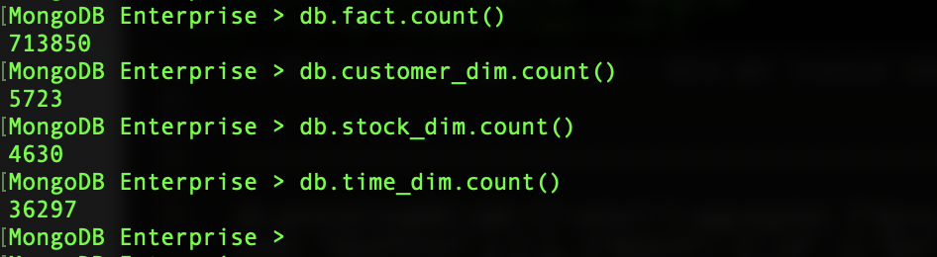

**Please note**: The **time_dim** collection was excluded (not deleted, only not used) for the **STAR schema** of the **Mongo DB** data-warehouse. The time related data (required in the aggregation queries) was fetched from the **FACT** collection itself for faster data retrieval. Joining data (using **$lookup** function) is quite expensive in **MongoDB**.

* + 1. **Aggregation Queries**
* **What time of the day is the sale maximum per country? (Query 1)**

We performed this query both with and without an index. Without index, this was the longest running query – taking a **whopping 16 minutes**. With an index, it took a much more reasonable **45 seconds**.

**Sample Output Data for Query 1 (when executed from MongoDB terminal)**

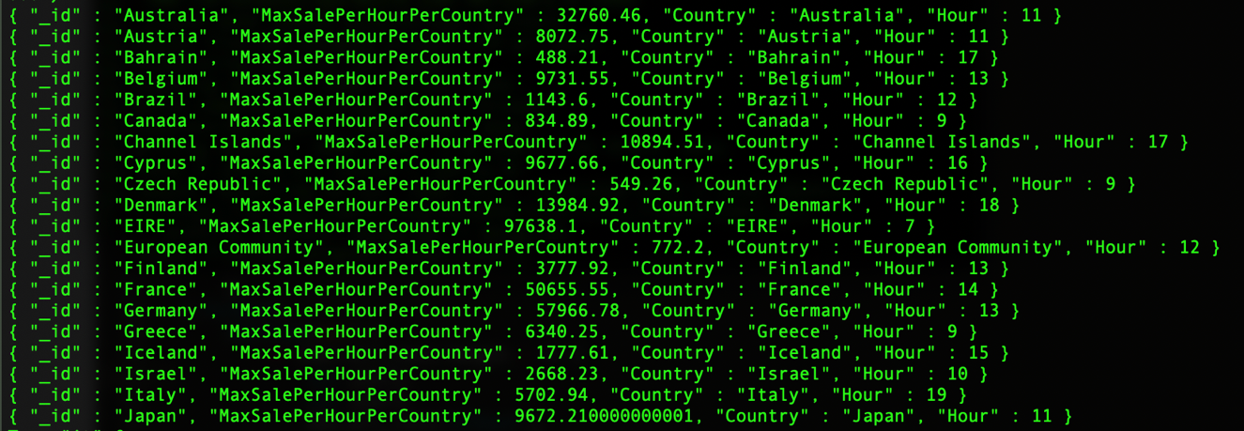

* **Annual Total Sales Per Product? (Query 2)**

This query required a grouping of ‘**Year**’, ‘**Stock**’ and sum of ‘**TotalSales**’ to produce ‘**TotalAnnualSales**’. Once the result set was obtained, ‘**$sort**’ was used to sort both ‘**Stock**’ and ‘**Year**’ in an ascending order. This took **a very minimal 2 seconds to execute**.

**Sample Output Data for Query 2 (when executed from MongoDB terminal)**

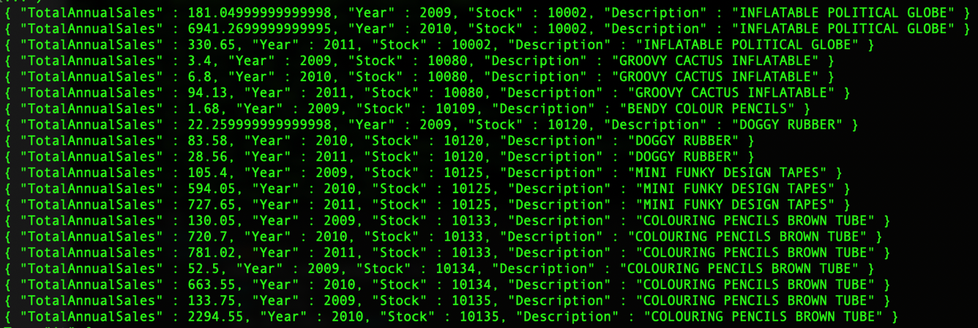

* **Top Product Per Year? (Query 3)**

This query required a grouping of ‘**Year**’, ‘**Stock**’ and sum of ‘**TotalSales**’ to produce ‘**TotalAnnualSales**’. The results were then sorted by ‘**Year**’. Execution time was once again, **minimal at 3 seconds**.

**Sample Output Data for Query 3 (when executed from MongoDB terminal)**

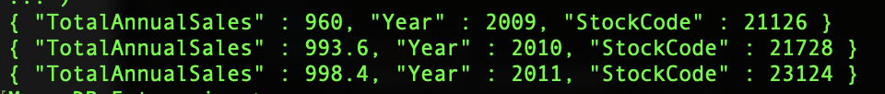

* **Top Product Per Country? (Query 4)**

This query required a grouping of ‘**Country**’, ‘**Stock**’ and sum of ‘**TotalSales**’ to produce ‘**TotalAnnualSales**’. The results were then sorted by ‘**Country**’. Execution time was **slightly longer at 52 seconds**.

**Sample Output Data for Query 4 (when executed from MongoDB terminal)**

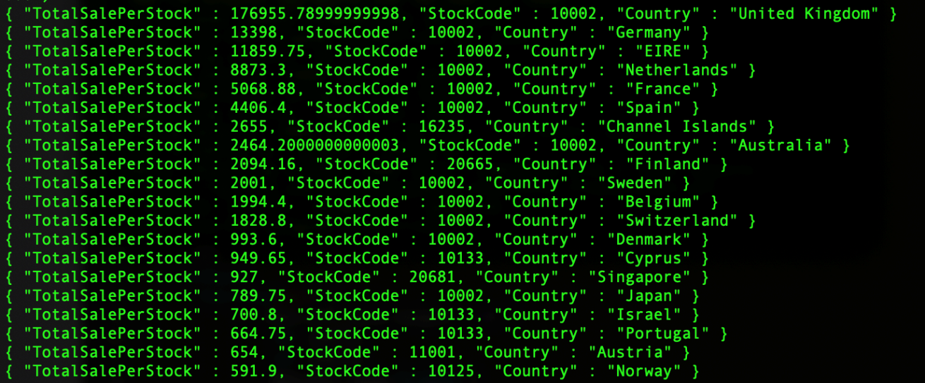

* **Which item is sold below the threshold value? Or, what are the under-performed products based on the average sales last year (the year denotes either 2009 or 2010)? (Query 5)**

For this query, threshold for a stock in a given year is devised by the average sale in the previous year. So, for any stock if there is sales record available for only one year, it is not considered. Also, if there are no record available for two consecutive years, the next available year is considered. For example, if for a stock we have data for the year of 2017 but no record for 2018 and then we have record for 2019, the records for 2019 is compared against 2017.

This query needed a total of three aggregation pipeline stages in MongoDB all run against the fact table. First is to do a grouping based on StockCode and Year to find out the total Quantity sold per stock per year and the total number of sales happened per year per stock. For faster result we can create an index based on StockCode and Year. In the next stage we do a sort based on StockCode and Year. In the third and final stage we do a group based on StockCode to get, for each stock, the total quantity of a stock sold per year and total number of sales for that stock in that year. We get the result of per year sales record of a stock as an array sorted by year under that stock.

The rest of the logic is done in JavaScript while iterating the resultant cursor, i.e. to find out the average sale for the previous year and if the current year’s average exceeds that average or not. The execution time of this query was approximately **3 seconds**.

**Sample Output Data for Query 5 (when executed from MongoDB terminal)**

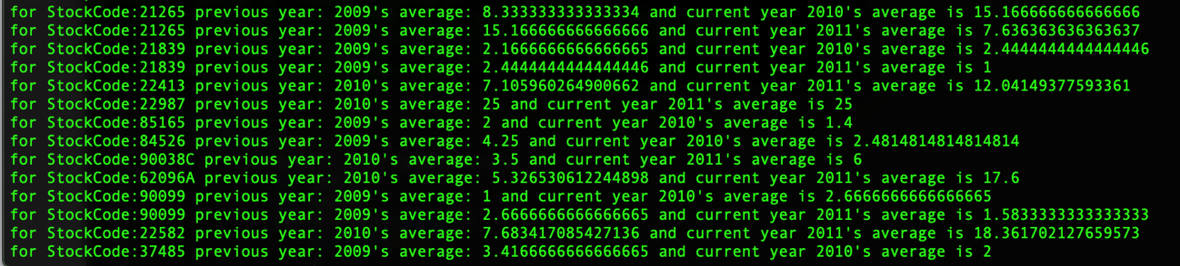

* **Which customer spends the most (per country or overall) (Query 6)**

This is a **two-part query**. We first attempted to find out which customer spends most overall. This query required a grouping of ‘**CustomerID**’ and ‘**TotalSales**’. An interesting aspect of this query is that initially, the execution, after running for over 10 minutes, produced a ‘**TimeOut Error**’. We remedied this by setting the ‘**allowDiskUse**’ **flag** to **true**. The execution took **8 seconds**. For the second part, we grouped together ‘**CustomerID**’ and ‘**TotalSales**’ along with ‘**Country**’. Per the learnings of the first part, we left the ‘**allowDiskUse**’ flag at true. The execution took **7 seconds**.

**Sample Output Data for Query 6 (overall) (when executed from MongoDB terminal)**

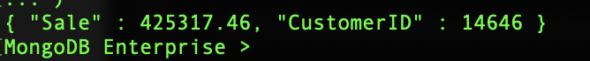

**Sample Output Data for Query 6 (per country) (when executed from MongoDB terminal)**

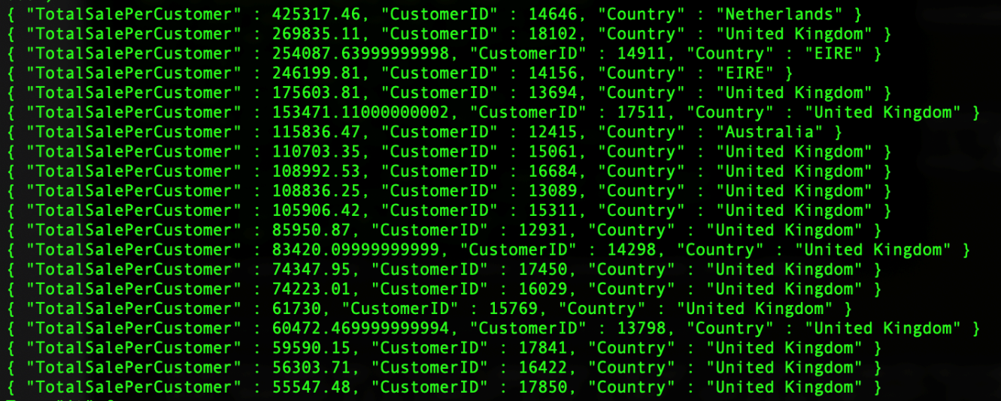

* **Best-selling month (per country) [2009-2011] (Query 7)**

This query utilizes the **‘$unwind**’ operator that allows us to examine each record in turn. Using that, we were able to extract the ‘**Country’** values and group by ‘**Country**’, ‘**Month**’ and sum of ‘**TotalSales**’. This data was then grouped separately to identify ‘**MaxSalePerHourPerCountry**’. Execution, due to sheer volume of calculation, was a bit **longer at 50 seconds**.

**Sample Output Data for Query 7 (when executed from MongoDB terminal)**

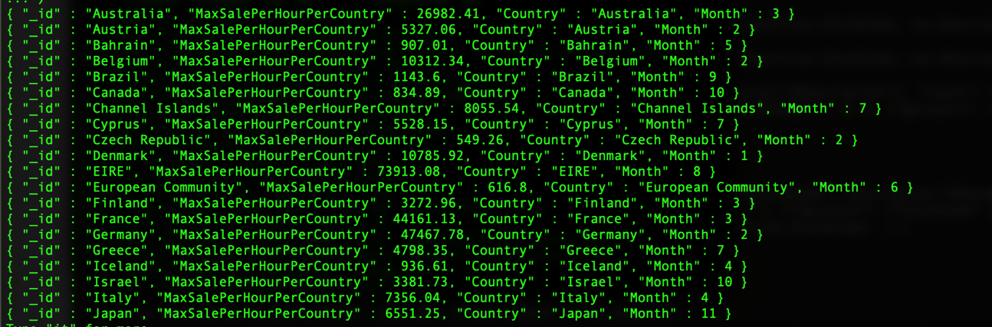

* **Best-selling product per month [2009-2011] (Query 8)**

This query required a grouping of ‘**Year**’, ‘**Stock**’ and sum of ‘**TotalSales**’ to produce ‘**TotalAnnualSales**’. The results were then sorted by ‘**Year’**. Execution time was once again, **minimal at 3 seconds**.

**Sample Output Data for Query 8 (when executed from MongoDB terminal)**

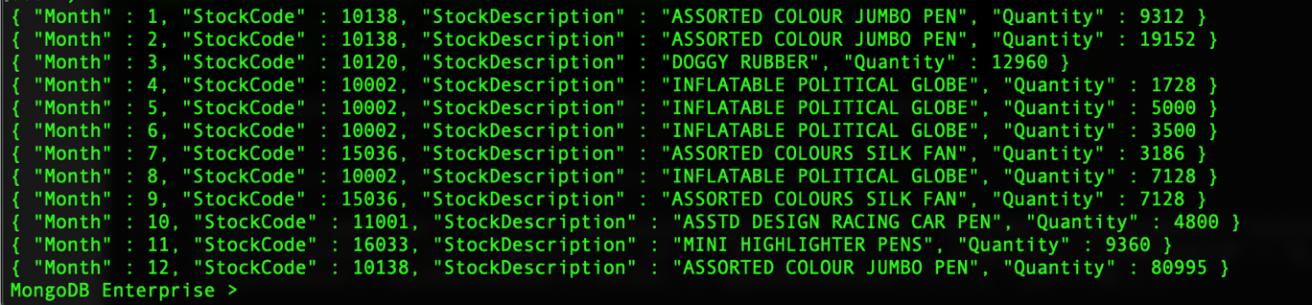

* **What is the change in total sales per country per year (trend of sales)? (Query 9)**

For this query, for any stock if there is sales record available for only one year, it is not considered. Also, if there are no record available for two consecutive years, the next available year is considered. For example, if for a stock we have data for the year of 2017 but no record for 2018 and then we have record for 2019, the records for 2019 is compared against 2017.

This query needed a total of five aggregation pipeline stages in MongoDB. First is to do a lookup between the **FACT** collection and the **customer_dim** collection based on **CustomerID** to get the **Country**, since Country is stored with the **CustomerID** in the **customer_dim** table. Then do a **grouping** aggregation based on **Year** and **Country** to find out the total sale per year per country for the second stage. The third stage is a **replaceRoot** to flatten out the structure. The fourth one, a **sort** based on Country and Year so that the records for per Country sales is sorted by Year. The fifth and final stage is one more **group** aggregate on Country to find out all the sales record available for that Country per year. The ‘per year sales record of a country’ is grouped into an array sorted by year under that country in the result.

The rest of the logic is done in **JavaScript** while iterating the resultant cursor, i.e. to **find out the sale for the previous year and to compare current year’s sales against that.** Surprisingly, despite of so many execution steps, the execution time of the query was 43 seconds.

**Sample Output Data for Query 9 (when executed from MongoDB terminal)**

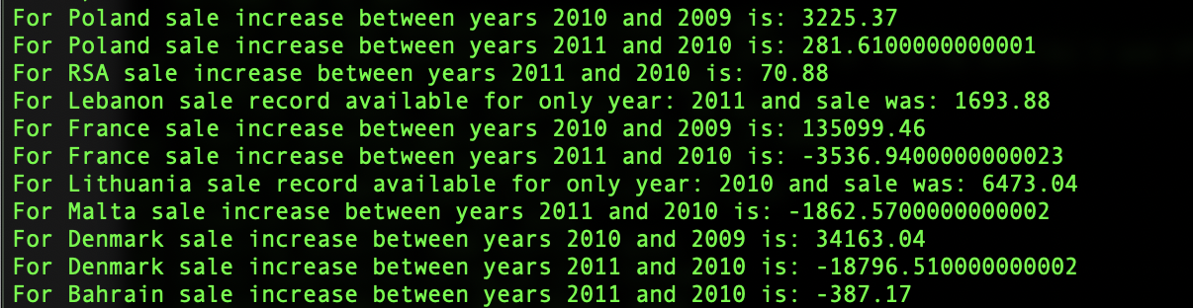

* **Average spending of customers in a country? (Query 10)**

This query required both ‘**CustomerID**’ and ‘**Country**’ from the ‘**Customer_dim**’ collection. The data was grouped by ‘**Country**’ and the average of ‘**TotalSales**’ was calculated. The results were then sorted and displayed. This query took slightly longer to execute at **51 seconds**.

**Sample Output Data for Query 10 (when executed from MongoDB terminal)**

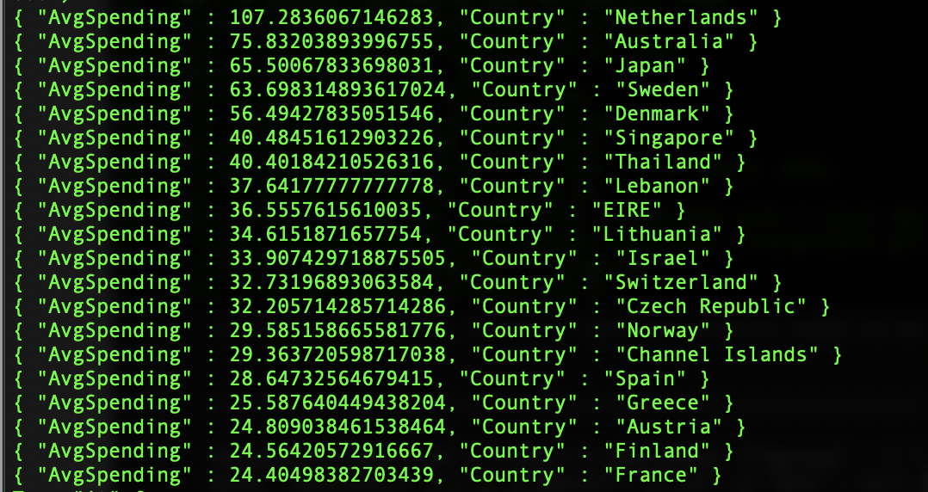

* **What is the frequently purchased item per customer? (Query 11)**

This query required a grouping of ‘**CustomerID**’ and ‘**StockCode**’ along with a ‘**$sum**’ variable in place to count the number of occurrences of an item. The results were then sorted by ‘**count**’. Execution time was once again, minimal at 3 seconds.

**Sample Output Data for Query 11 (when executed from MongoDB terminal)**

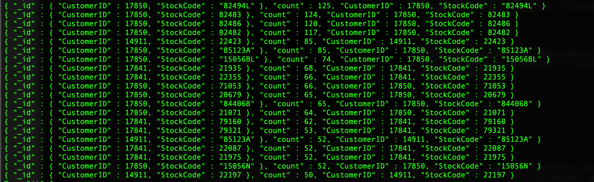

**Please note:** The execution times of all the above stated queries may vary slightly depending on the system configuration.However, when the queries were executed on different systems, the difference in execution-time was barely few seconds.

The above queries were executed on the following system configuration:

**Processor: 2.7 GHz Quad-Core Intel Core i7**

**Memory: 16 GB**

**MacOS**

* + 1. **Challenges of MongoDB**
* It has a steep learning curve on how the query and aggregation and aggregation pipeline and stages work along with various accumulation functions available in different aggregation stages and in the query (**find**) process. **Also, learning about memory utilization in mongodb in various stages and how indexes plays their part on that has been enlightening**.
* The main challenge in **ODB** database was to split the **InvoiceDate** and **InvoiceTime** into individual **Year**, **Month**, **Day**, **Hour**, **Minute** (as the Date and Time were already split in the initial part of the data cleaning). Hence, we imported the **csv file to Python** to do the date and time splitting.
* An interesting challenge in MongoDB is that, unlike SQL, there is no direct option to insert files in a collection by selecting them from another. So, while creating the ADB tables, we had to read the data record by record and utilize the ‘**forEach**’ function to insert them. However, we realized later that there is a command called ‘**mongoexport**’ which can export columns from a collection (of one database) to a collection (of another database) very easily. (from odb to adb in our case)
* While we did create the ‘**Time_Dim**’ collection, we did not need to utilize it in any **MongoDB** query execution.
* While processing data from more than one collection, indices were needed to fasten query execution. Without creating an index for the ‘**Stock_Dim**’ collection, for instance, several queries would have taken far longer to execute.
* For queries 4, 6, 7, 8, 9, 10 and 11, we set the ‘**allowDiskUse**’ parameter to **true**. This enables writing to temporary files. When set to true, most aggregation stages can write data to the **_tmp subdirectory** in the **dbPath directory**. This vastly sped up the execution of queries – **from over 10 minutes** (and an **ExceededMemory Error**) to **8 seconds** in the case of **Query 6**.
  + 1. **Advantages of MongoDB**
* The primary advantage of **MongoDB** is its **speed**. MongoDB can very quickly query and return results from very large data sets. Insertion of over **700,000** records took relatively minimal time. This presents major advantages in terms of processing time but also the volumes the database can handle. The **FACT** collection insertion took **5 minutes**, ‘**Customer_dim**’, **6 minutes** and ‘**Stock_dim**’, **4 minutes**. ‘**Time_dim**’ was split due to the creation of the ‘**time_dim_temp**’ collection. This took **4 minutes and 53 seconds**. The creation of the final ‘**time_dim**’ collection only took **13 seconds**.
* Additionally, we appended two cleaned csv files to a single file. This was because each import command in MongoDB (one for each csv file) took around 40 seconds. So, importing 2 csv files would have taken around 80 seconds. After combining the two files into one file, the import command took around 45 seconds, which means we saved around 35 seconds. While this seems rather trivial, it does speak to MongoDB’s ability to handle large volumes of data.
* While Relational Databases would require views to speedup query execution, this was not required for MongoDB.
* While sending data to the **User Interface** (**UI**), we are spared from doing further transformation of data in **MongoDB**.
  + 1. **Disadvantages of MongoDB**
* **Multiple joins(lookup)** is not advisable in **MongoDB** as it is meant to be a database where **data needs to be denormalized as much as possible**. Each join reduces performance of the entire operation. **Indexes** help them make better, however, if we need queries that needs us to join more than a few collections, **MongoDB is not advisable**.
* In **MongoDB**, the methods available in an **aggregation stage** or in a **find operation** and their behavior is **limited** and **quite rigid**. Also, since the output of MongoDB is in JSON format, there are limits on the operation and calculations that can be achieved using only MongoDB scripts. For example, **the queries #5 and #9 required extensive calculation on the output of the aggregation which was not possible only through MongoDB scripts. So, some of it was delegated to the caller function.**
  1. **Neo4j**
     1. **ODB Creation**
        1. **Creating CSVs**
        + We must change the column "Customer ID" to "CustomerID" in both Excel Files
        + We must save the files in a CSV format
        1. **Importing the Data**
        + Must store both the CSV files in the import folder of the Database
        + We will have to use the following queries to import the data and store it into nodes with the label ODB
        + Each entry in the CSV is converted into a node with the label ODB with each column as a property

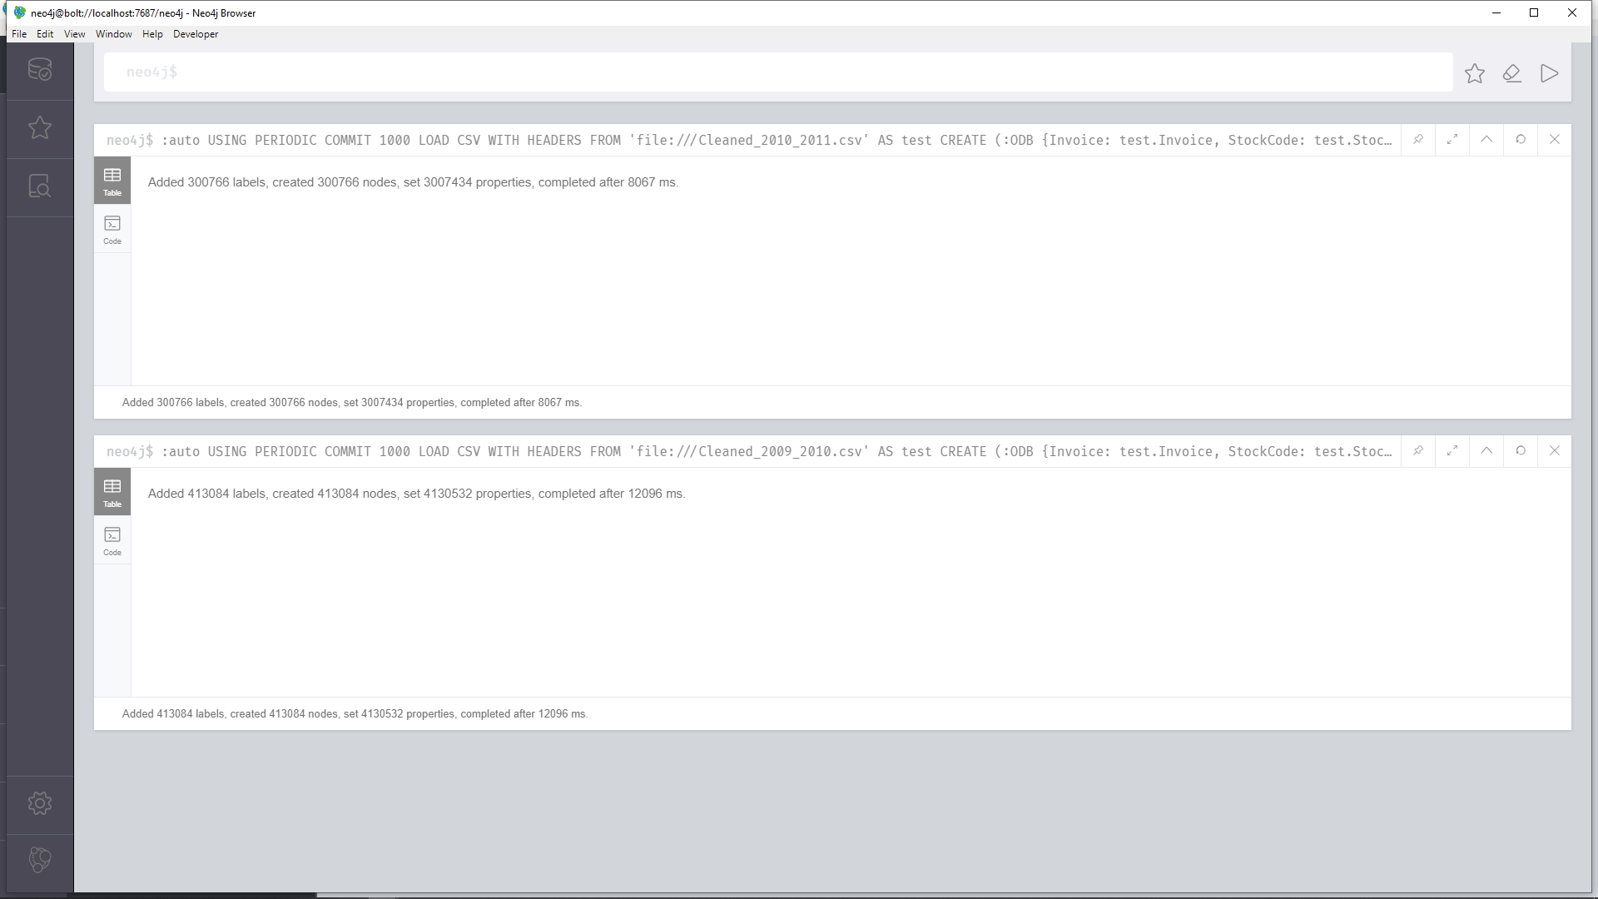

* + - 1. **Cleaning the ODB**
      * We will have to convert the values of InvoiceTime and InvoiceDate into a format which is understood by Neo4j

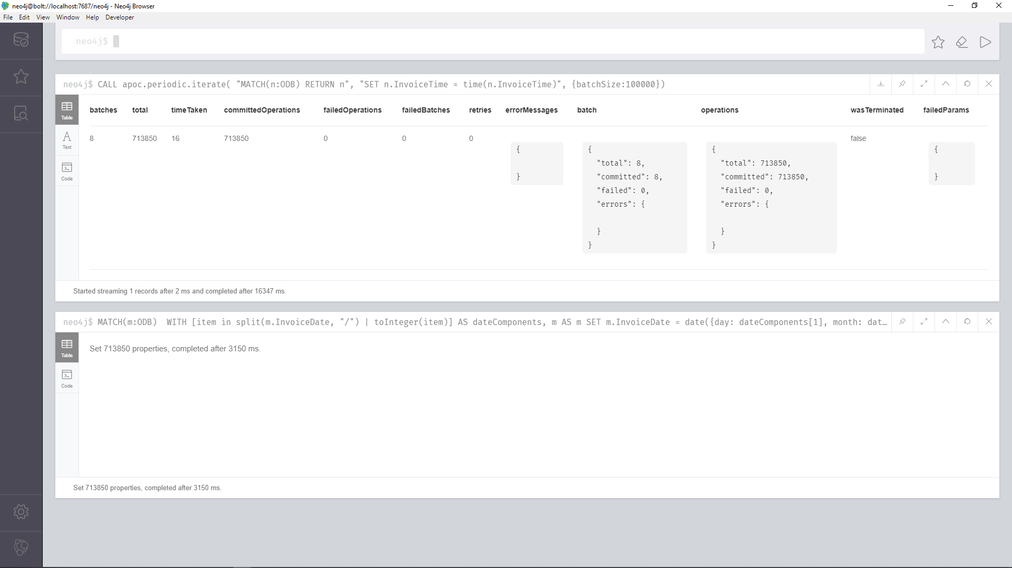

* + 1. **ADB Creation**
       1. **Adjustment to the Star Schema by adding TimeID**
* We have added TimeID to the FACT table and the TIMEDIM table.
* This has been done as Neo4j does not handle the creation of a relation using multiple properties very will leading to a very inefficient query.
* Without the TimeID the query would run for 6+ hours if the dbms.memory.heap.max_size configuration is changed from 1GB to 10GB in the config file.
* This was unacceptable and for the query to run in a timely manner we added TimeID
* The TimeID property is not used in anything except the creation of the relation between the FACT table and the TIMEDIM table.
* Since we do not use the TIMEDIM table we do not need it and it can be removed
  + - 1. **FACT**

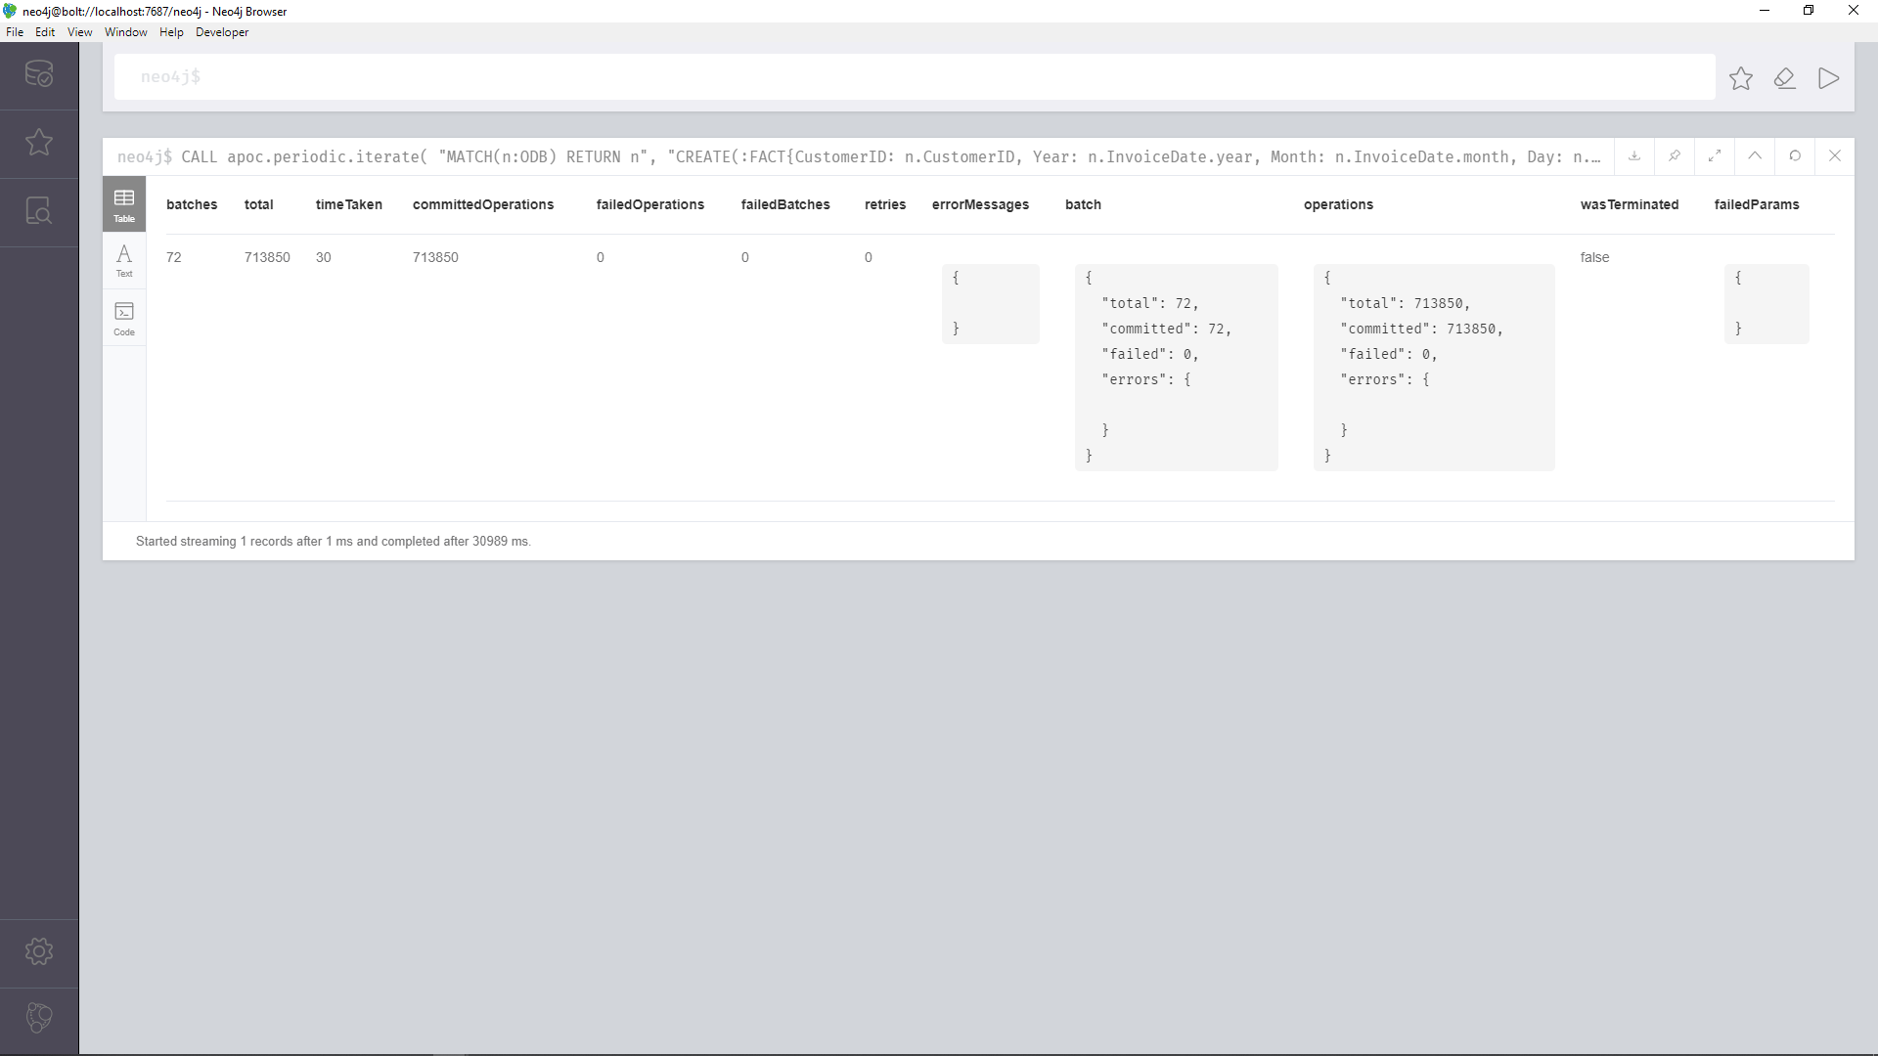

* + - 1. **CUSTOMERDIM**

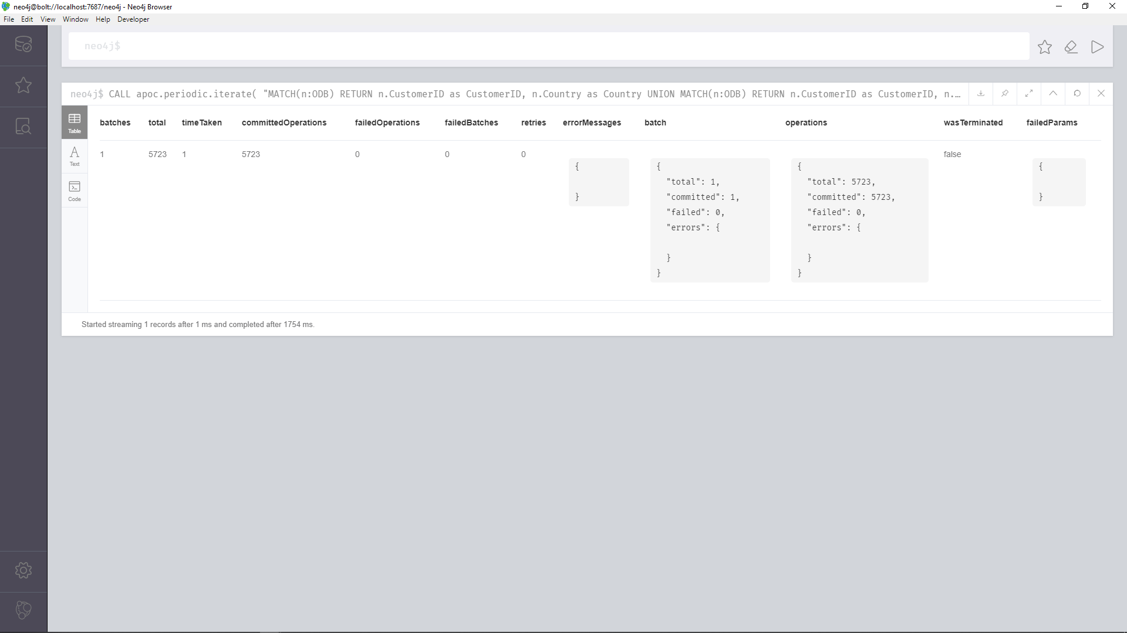

* + - 1. **TIMEDIM**

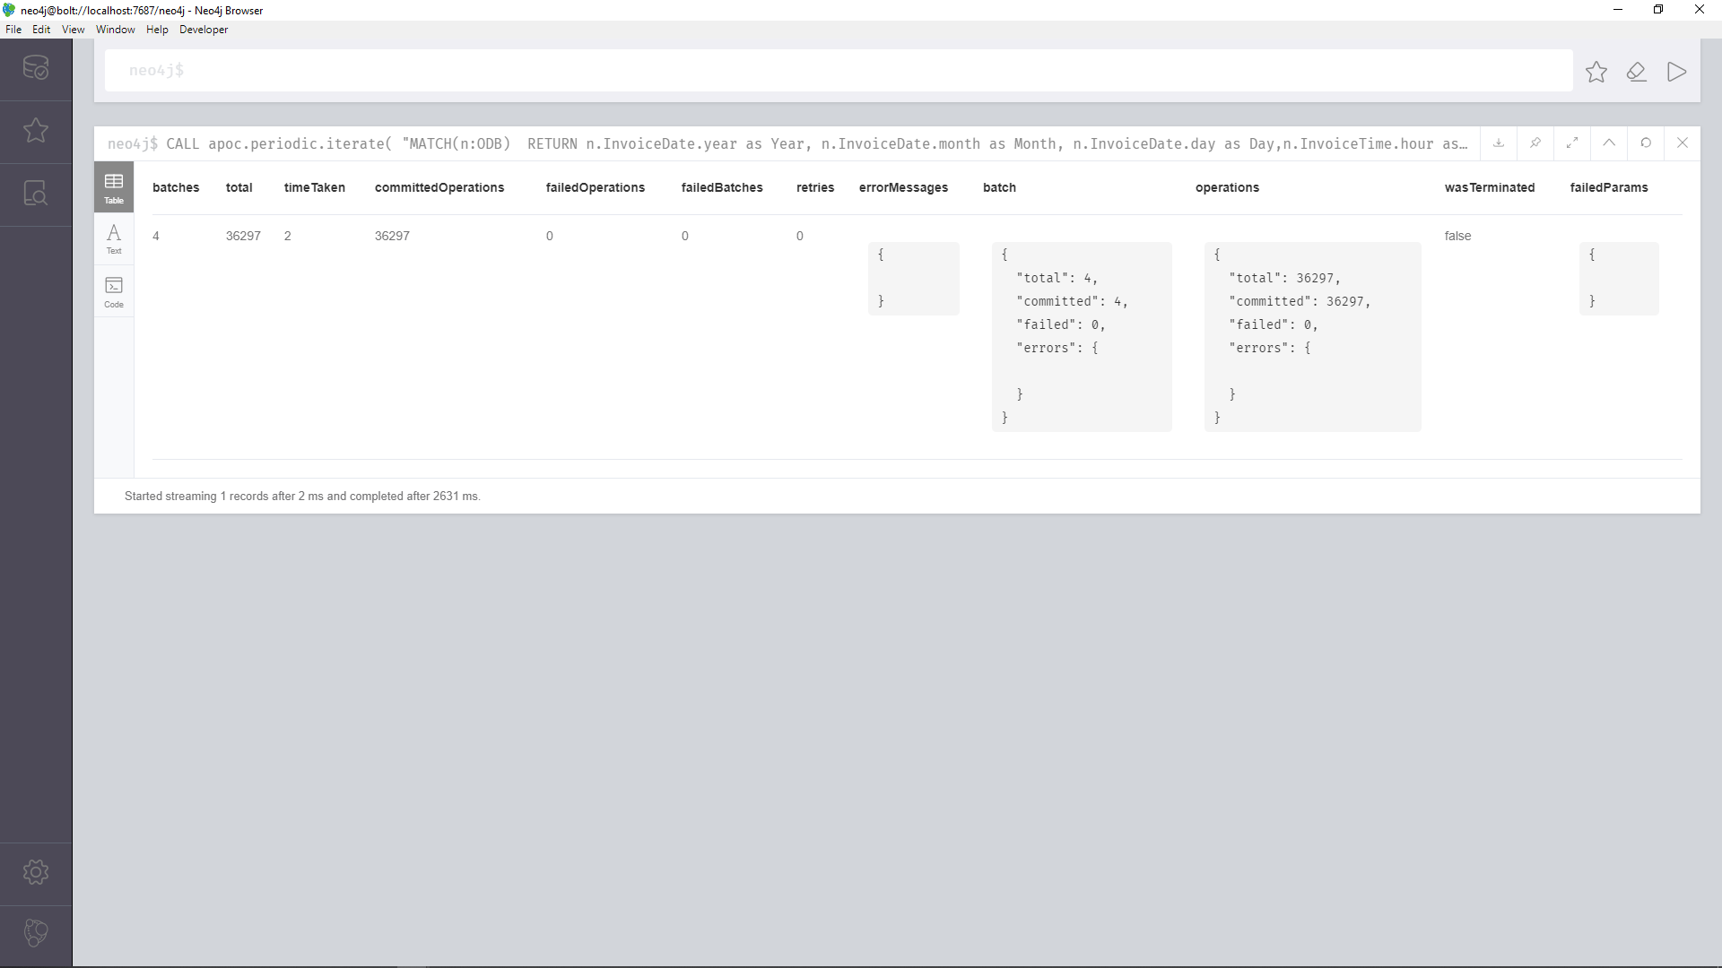

* + - 1. **STOCKDIM**

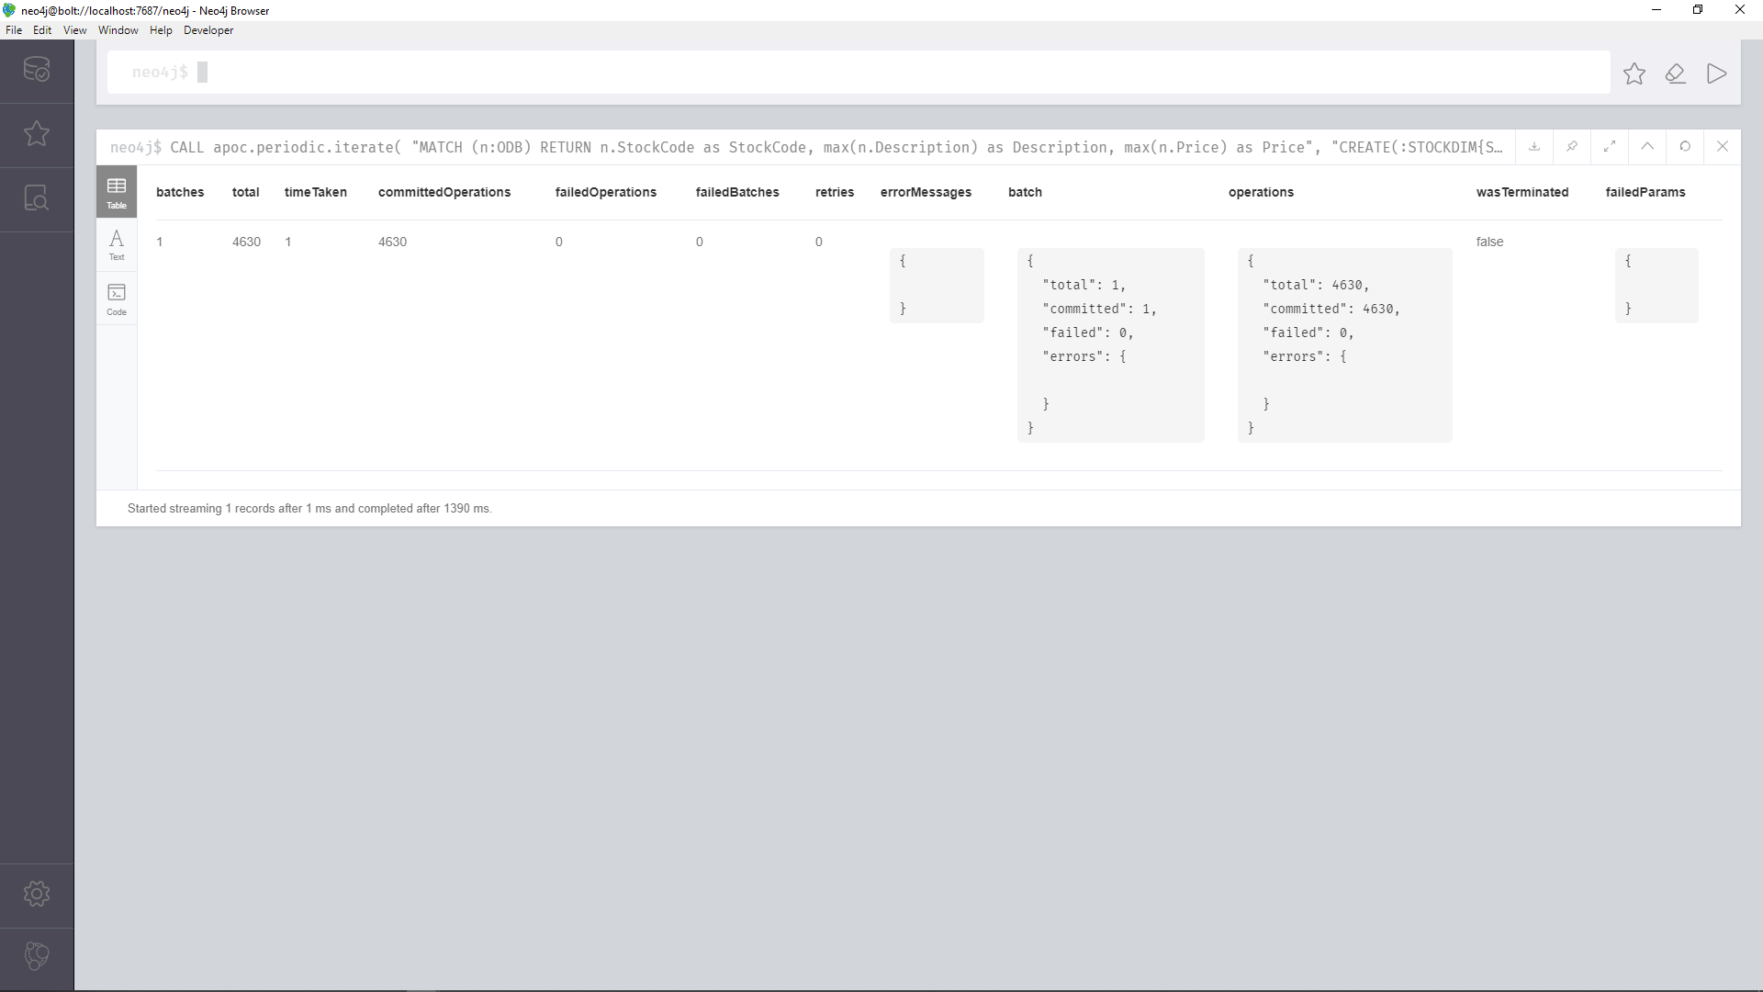

* + 1. **Creating the Relationships between the tables**
       1. **Creating Relationship between FACT and CUSTOMERDIM**

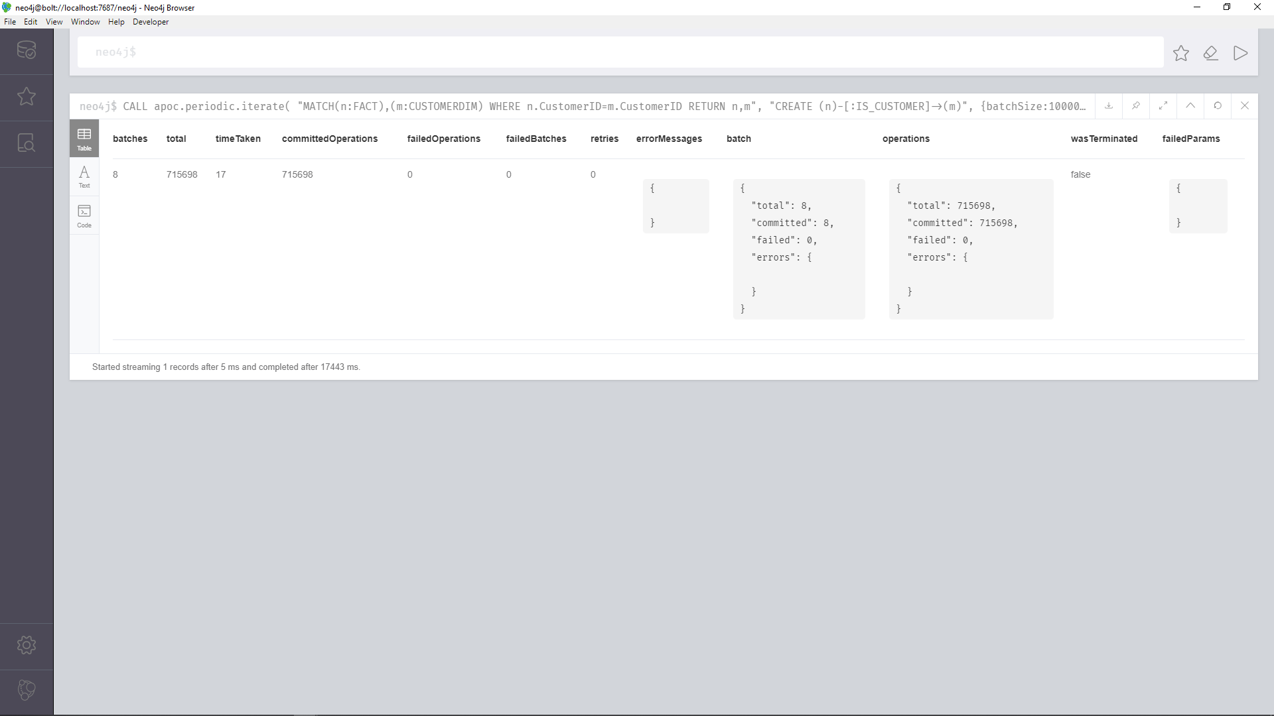

* + - 1. **Creating Relationship between FACT and STOCKDIM**

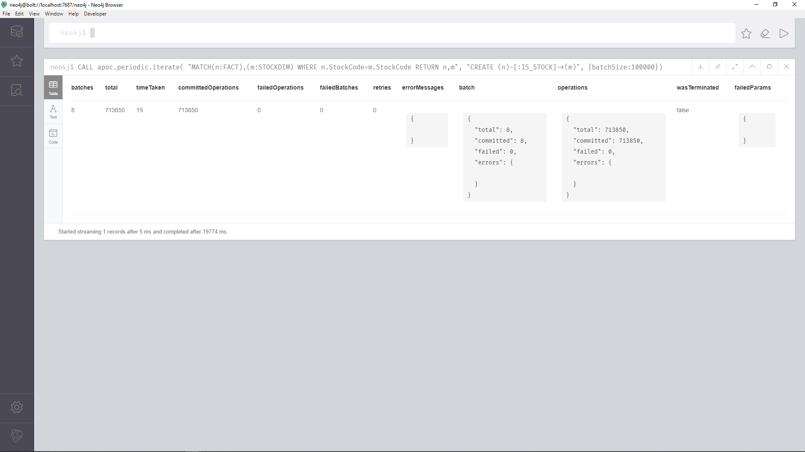

* + - 1. **Creating Relationship between FACT and TIMEDIM**

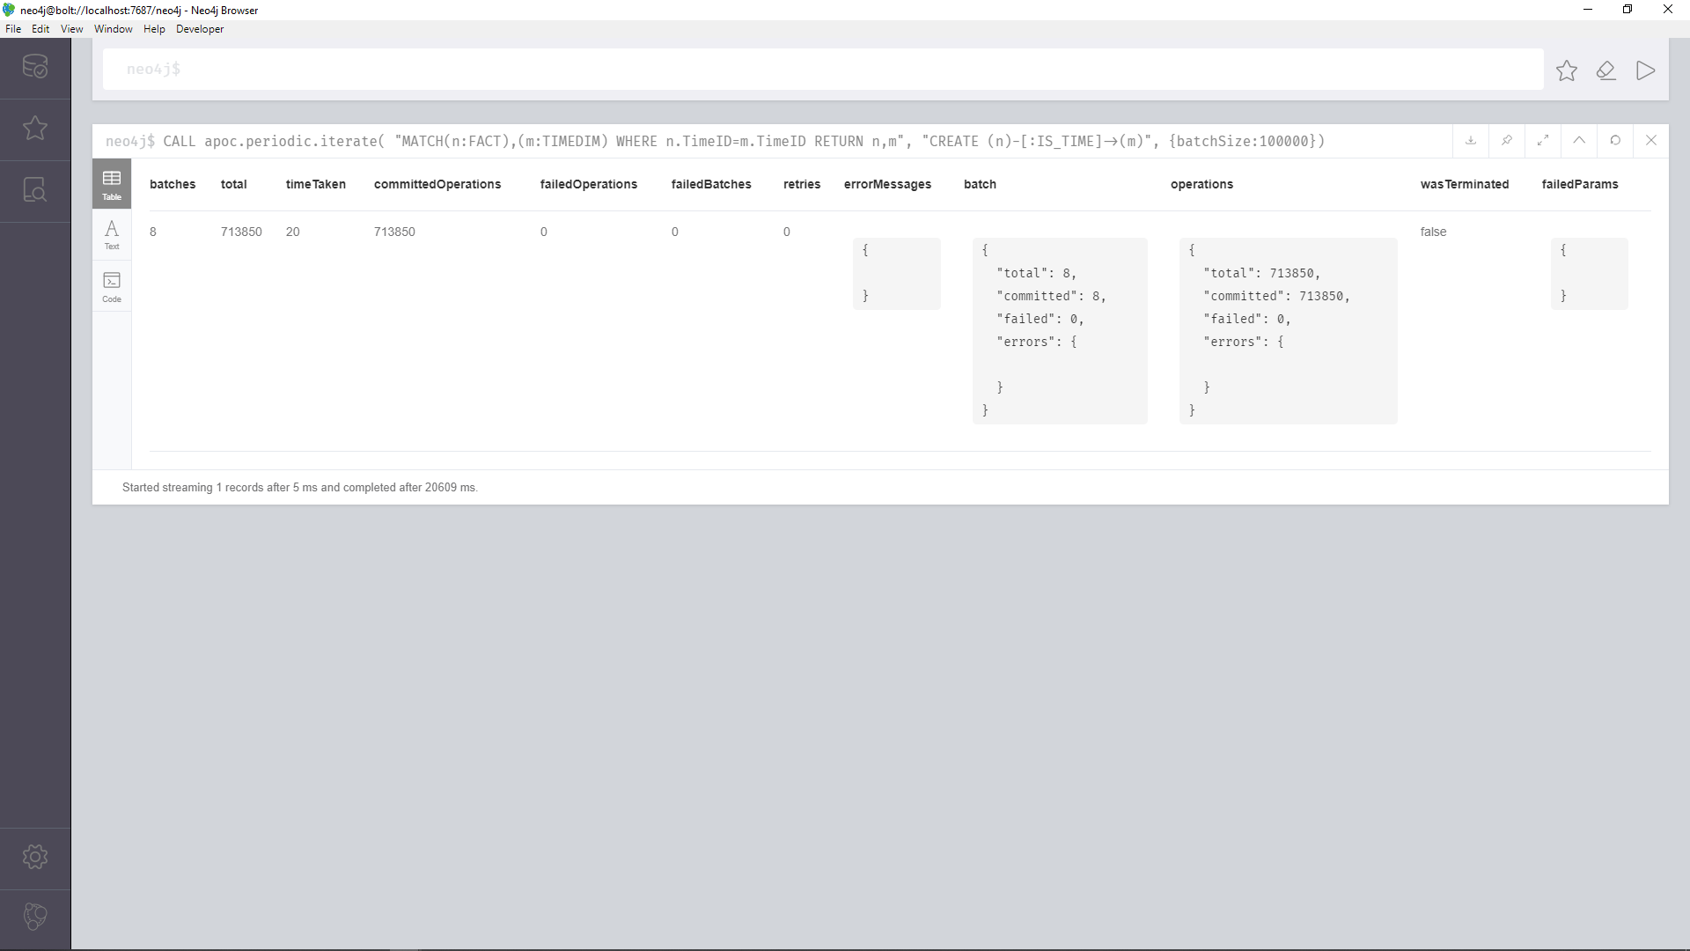

* + 1. **Aggregation Queries**
       1. **What time of the day (which hour of the day) is the sale maximum per country?**

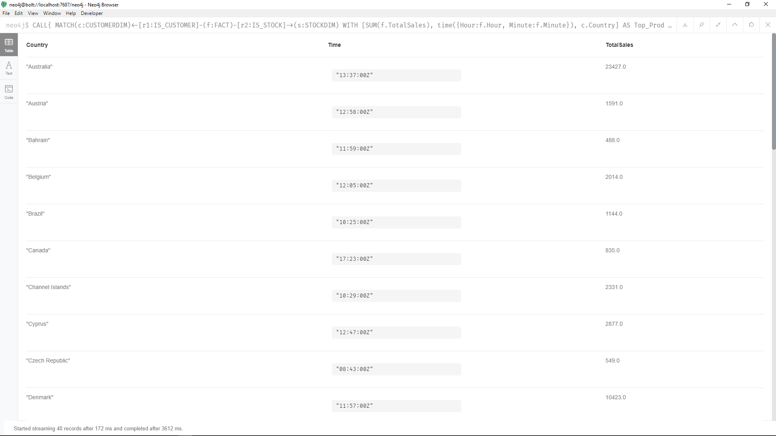

* + - 1. **What is the annual TotalSales per product?**

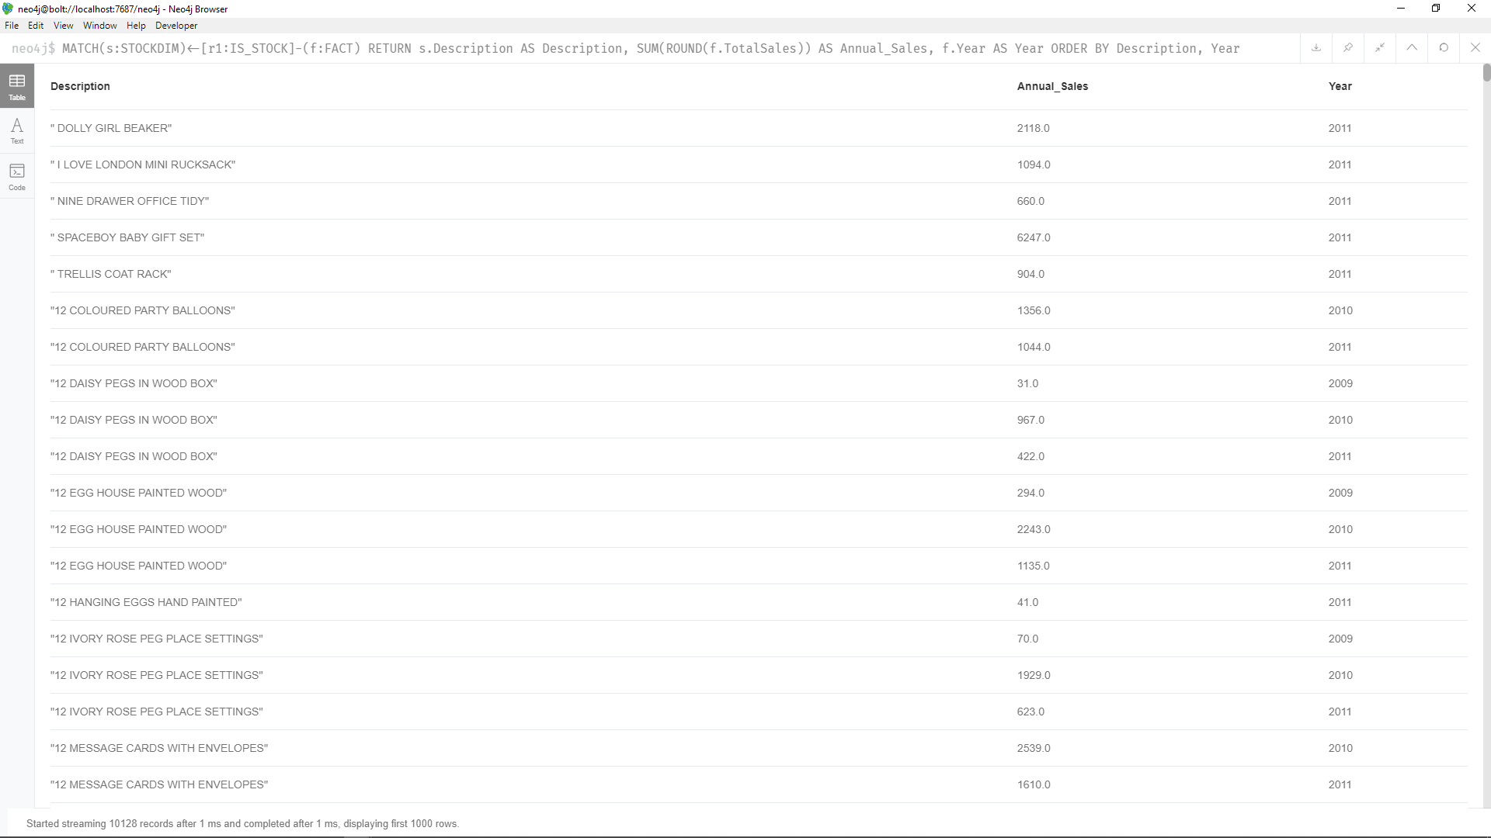

* + - 1. **What is the top product per year?**

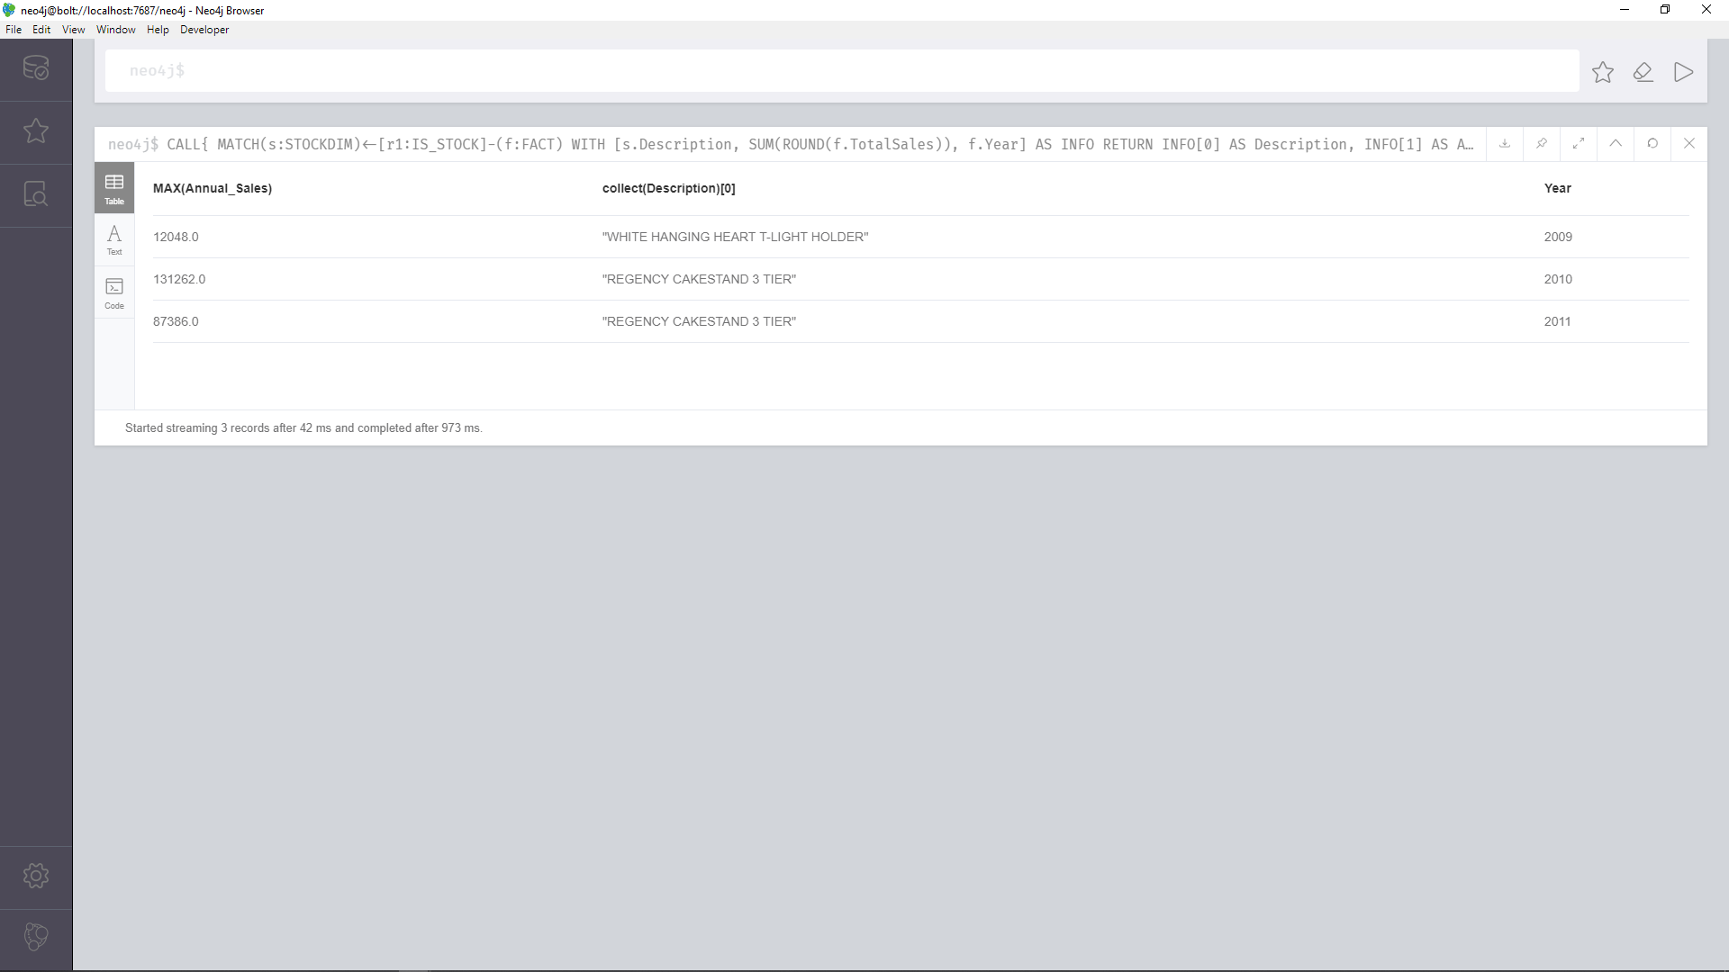

* + - 1. **What is the top product per country?**

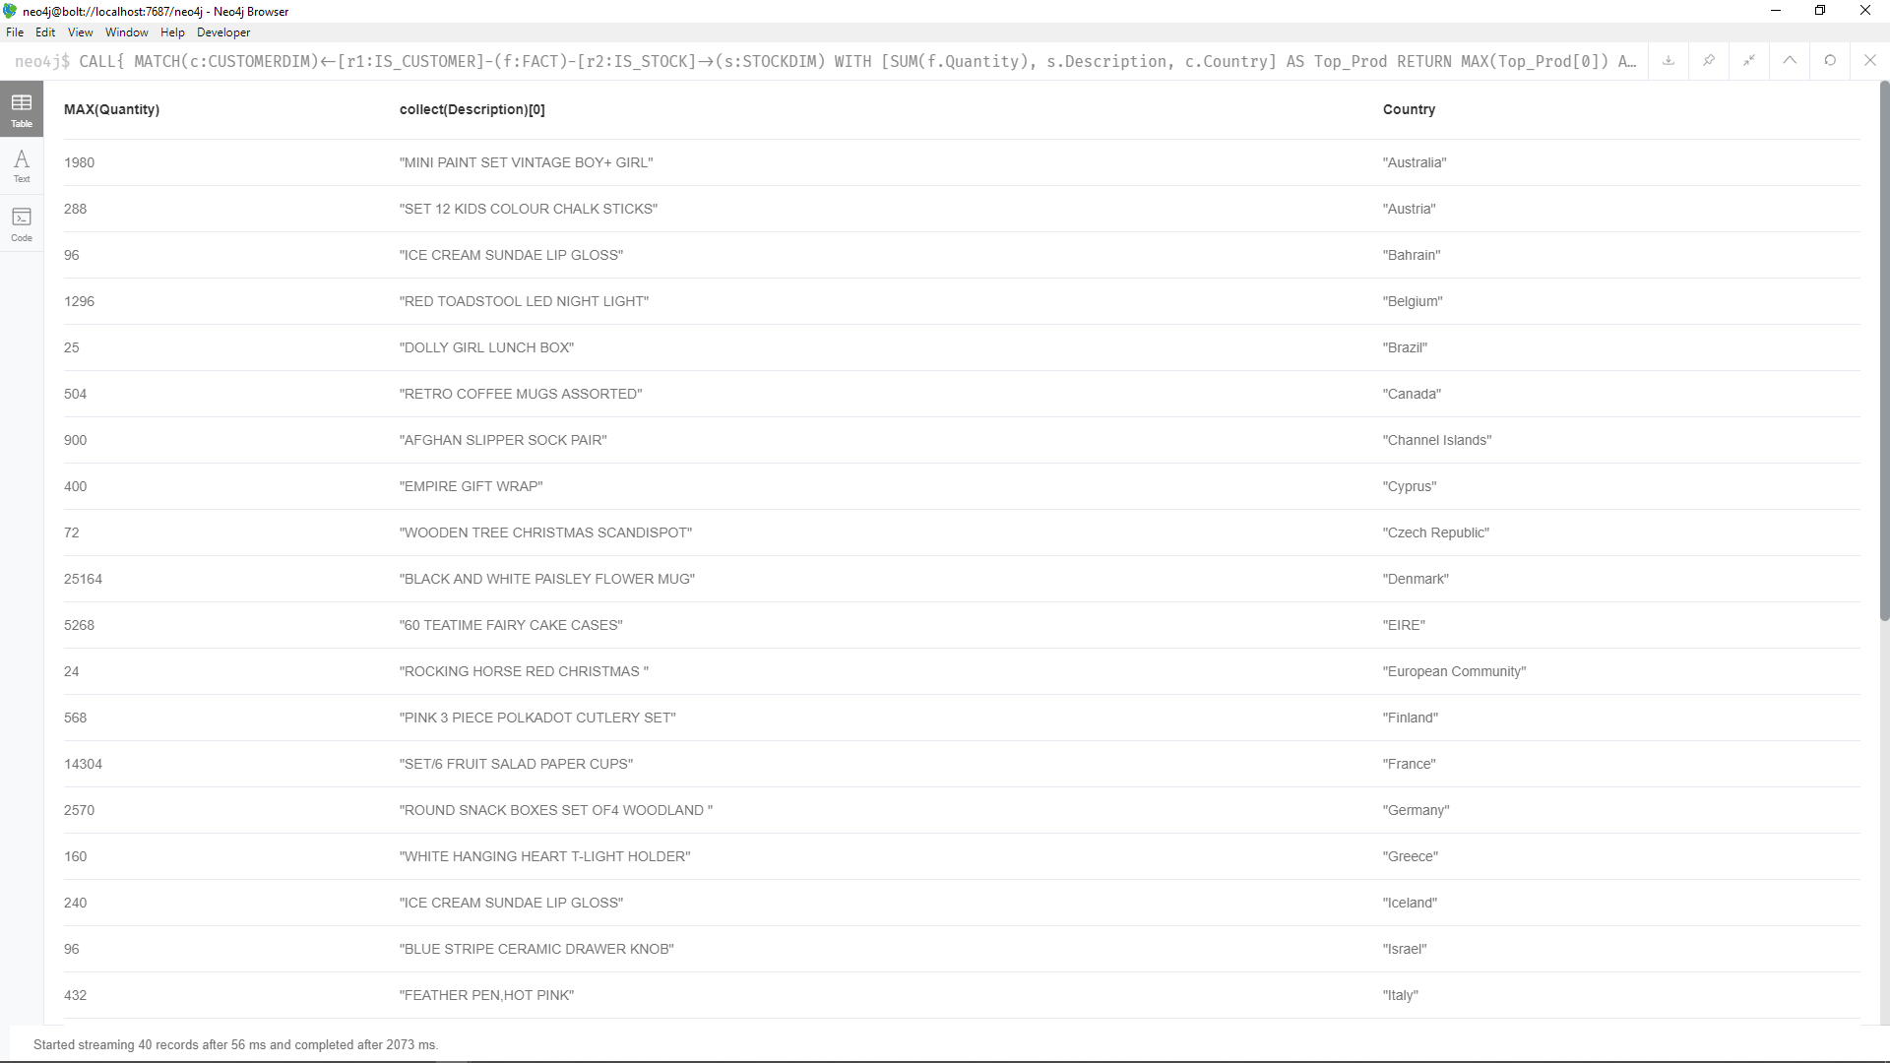

* + - 1. **Which item is sold below a certain threshold value? Or, what are the under-performed products based on the average sales last year?**
      2. **Which customer spends the most per country?**

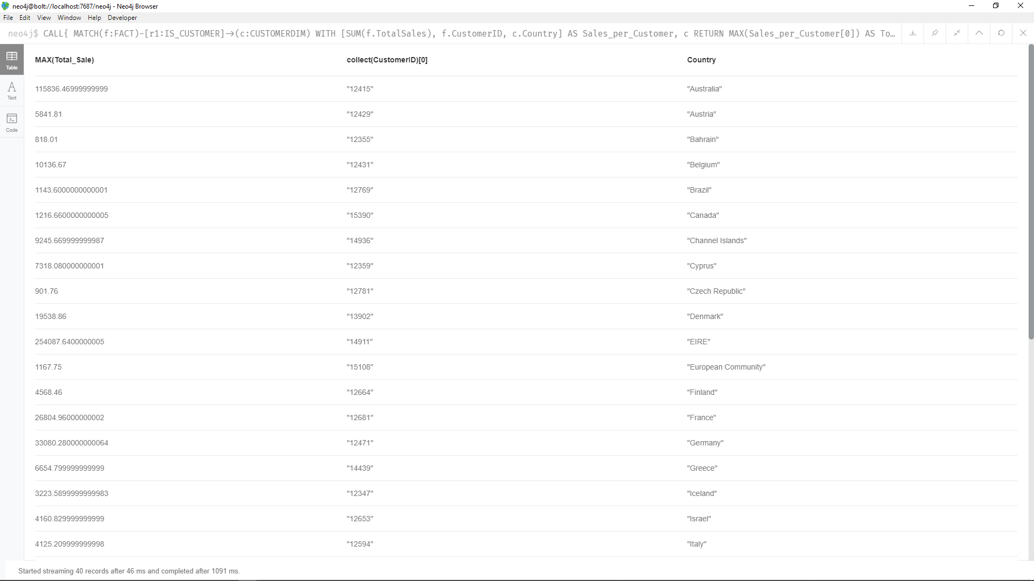

* + - 1. **What is the best-selling month per country? (Given the year range, 2009-2011)**

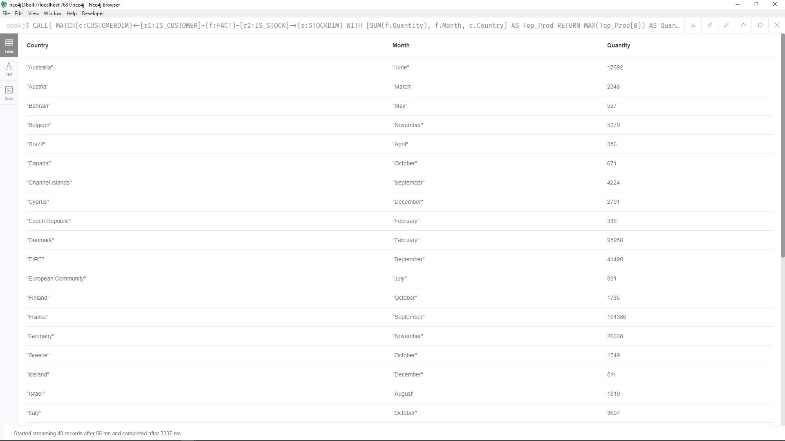

* + - 1. **What is the best-selling product per month? (Given the year range, 2009-2011)**

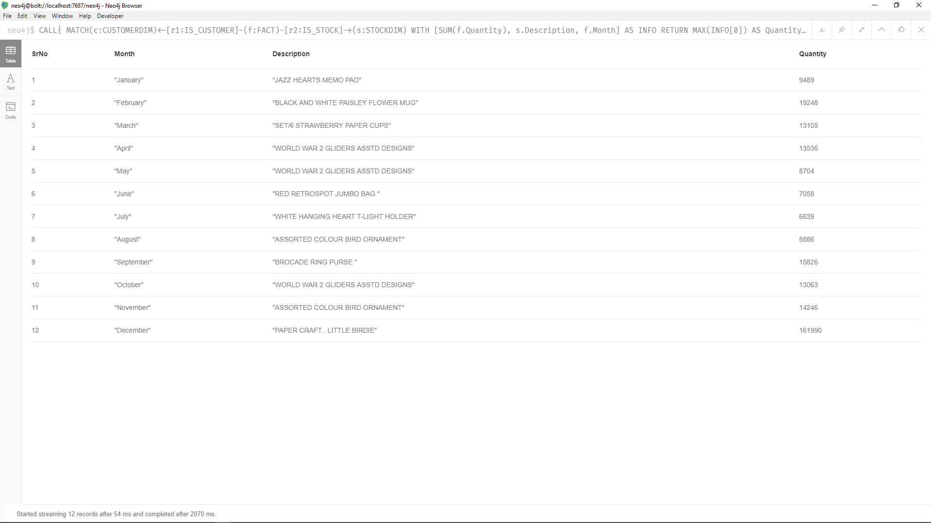

* + - 1. **What is the change in TotalSales per country per year (Trend of Sales)?**
      2. **What is the average spending of a customer per country?**

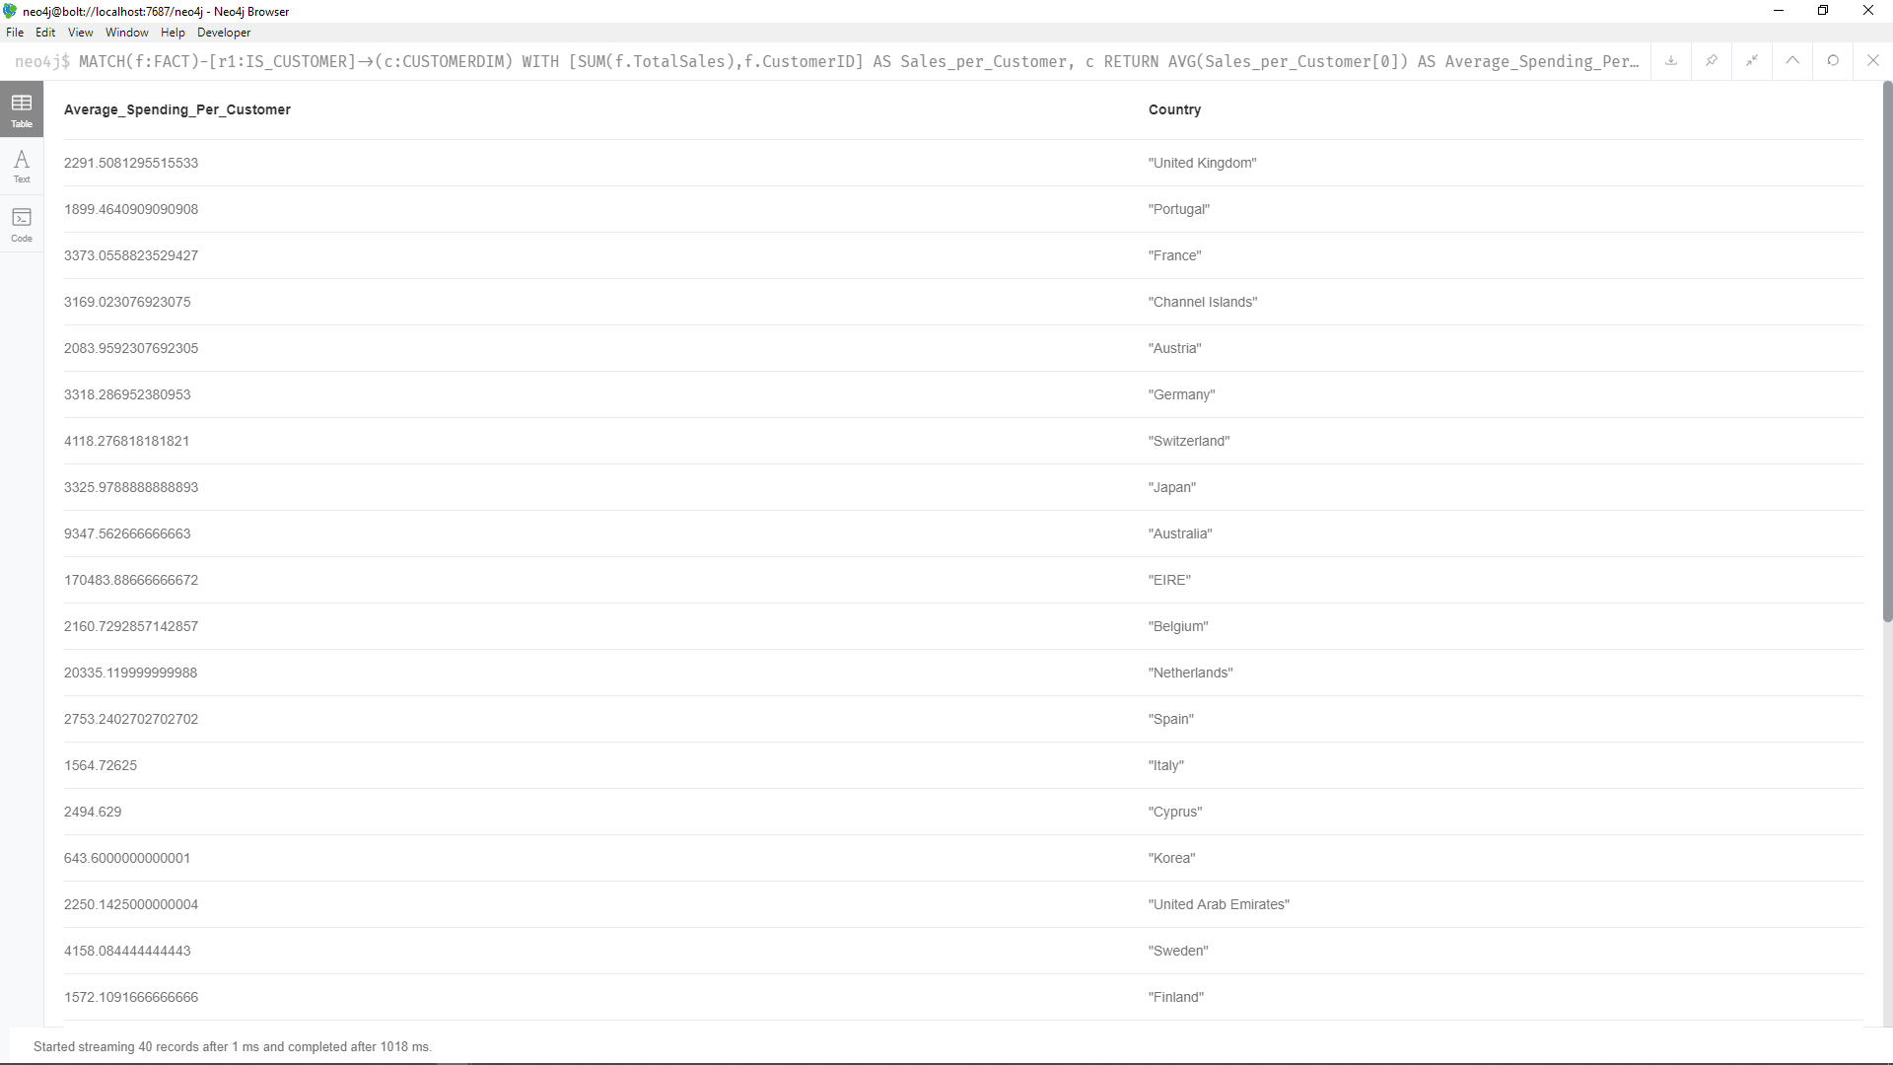

* + - 1. **What is the frequently purchased item per customer?**

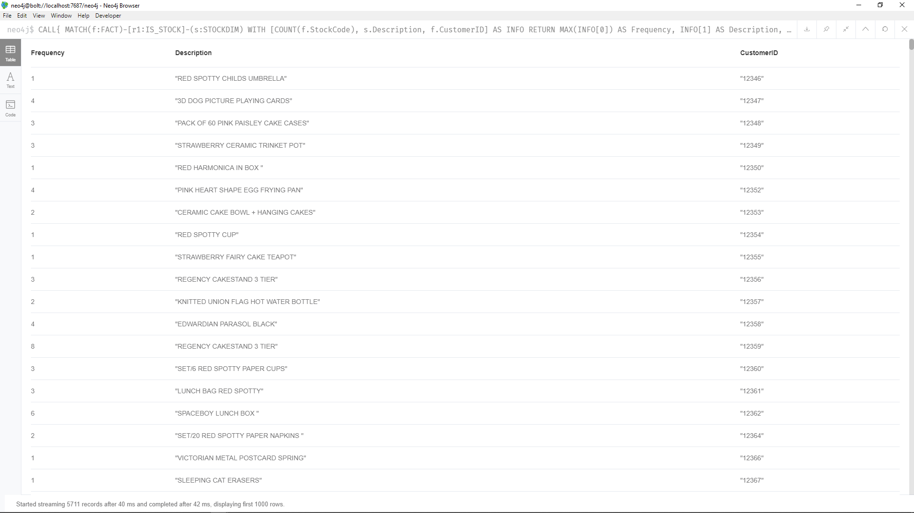

* + 1. **Explanations**
       1. **Creating ODB**
* In the query we use to import the information from the CSVs and load into the ODB we use :auto USING PERIODIC COMMIT 1000.
* This tells Neo4j to commit changes every 1000 rows of the CSV.
* Using this we don’t have to import the entire CSV file in batches manually as the database does it for us.
  + - 1. **Cleaning InvoiceDate and InvoiceTime**
* When we load the CSV into the ODB the values of InvoiceDate and InvoiceTime are strings and we need to convert them into a format which is used by Neo4j.
* For this we use the DATE() and TIME() functions for InvoiceDate and InvoiceTime respectively with some string manipulation for InvoiceDate
* We must use apoc.periodic.iterate because Neo4j cannot compute the conversion of InvoiceTime with the hardware constraints.
  + - 1. **Creating Tables in ADB**
* We create the tables from the ODB using apoc.periodic.iterate() function
* This function allows us to select the information we need from the ODB in the inner query and create new nodes using the outer query in batches so that the system isn't overloaded.
  + - 1. **Queries 1, 3, 4, 6, 7, 8 and 11**
* In these queries we use a Neo4j function “CALL”. This function allows us to take the returned values from a query and perform a second RETURN function on them.
* All these queries function using a similar technique. We use the query in the CALL to order the results using aggregations or the ORDER BY function.
* We can then use the COLLECT() function or any other aggregation we want to get our results.
* For example, in Aggregation query 3 we need to find the Top product per country.
* So, first we RETURN the SUM of Total Sales AS Annual Sales, Description and the Year, we ORDER BY Annual Sales in the descending order and then by Year. This will order the results with the highest Annual Sales first
* In the RETURN of the CALL we can use COLLECT() to combine all rows with the same Description and display the first value.
* Since we had ordered them from the largest value of Annual Sale to smallest. The fist value in the COLLECT() would be the description of the item which sold most in that year.
* We also use MAX of the Annual Sales to display the value for the respective Description
* Since we have not aggregated Year, we get all the values for it
* This gives us the result we need.
  + 1. **Important Notes**
       1. **Query 5 and 9**
* Both the queries require some conditional filtering after aggregation.
* In order to have multiple aggregations we need to use the CALL function in Neo4j.
* CALL allows us to perform more aggregations on the RETURN values of a query. However, this can only be done using a RETURN statement.
* Due to this we cannot use any conditional filters or conditions.
* This is one of the drawbacks of Neo4j we have found.
* However, in a practical setting where we can use other languages this issue can be worked around.
  + 1. **Advantages of Neo4j**
* By creating relationships between the nodes and effectively converting out database into a graph, thus we are avoiding the need to define joins in the query saving time.
  + 1. **Disadvantages of Neo4j**
* There are no nested aggregations in a straightforward manner they must be done using the CALL function
* Cloning nodes is a very slow process and must be done using the APOC plugin for many entries
* Creating Relationships between nodes using multiple properties is a very slow and memory intensive process
* The call function does not allow any additional conditional filters
* There is no flexible way to create nested queries
* There is no Group By but there are aggregations which are not as flexible as they don't allow aggregation based on a category
* There is no way to create a View in Neo4j
  + 1. **Where Neo4j shines**
* Due to the nature of Neo4j being a graphical database it lends itself very well in a situation which the data can be expressed in a graph. For an example a Social Network where each node can be a person or a page and is linked to others via relationships.
* Neo4j can also be used in a system where the data has been normalized into multiple tables and needs to be joined frequently. For example, the database of a multinational company, here we can use relationships to create a permanent SQL like join between the tables. This can speed up the queries which require joins but do not have a lot of aggregation.
  1. **Front-End**

1. **Comparison**

**(Filled by the person on whose laptop presentation will be done)?**

|  |  |  |  |
| --- | --- | --- | --- |
| **Notable Features** | **Databases** | | |
| **SQL DB** | **Mongo DB** | **Neo4j** |
| **Data Loading** |  |  | **Has automated batch loading** |
| **View Materialization** |  |  | **Is not required** |
| **Joining Tables/Collections/Nodes** |  |  | **Permanent Relationships between nodes** |
| **Index Creation** |  |  | **Single and composite indexes can be created on node properties** |
| **Large Data Handling** |  |  | **Vertical data is not handled well, Horizontal data is** |
| **Query Execution Speed** |  |  | **Fast** |

1. **Conclusion**

**APPENDIX A**

**ODB Creation**

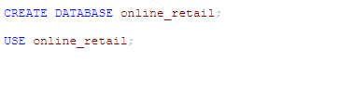

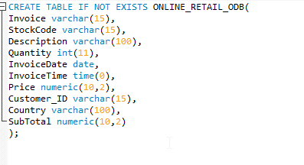

**ADB creation**

**Creating the FACT Table (From ODB to ADB)**

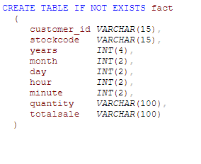

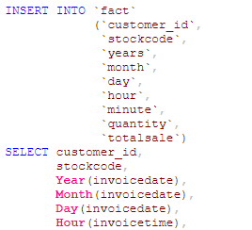

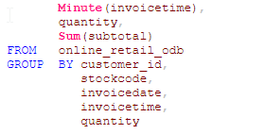

**Creating the CustomerDim table (From ODB to ADB)**

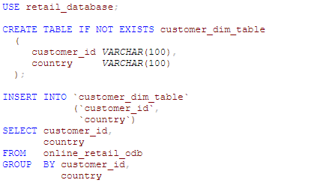

**Creating the StockDim Collection (From ODB to ADB)**

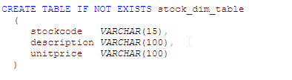

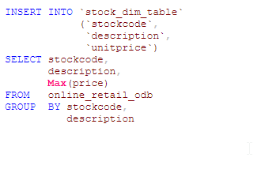

**Creating the TimeDim Collection (From ODB to ADB)**

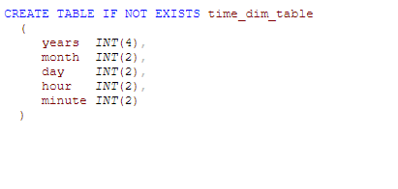

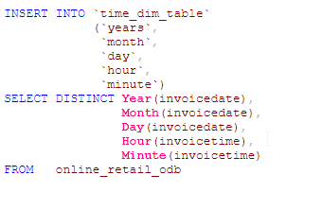

**Aggregation Queries**

1. **What time of the day is the sale maximum per country?**

**SQL Query:**

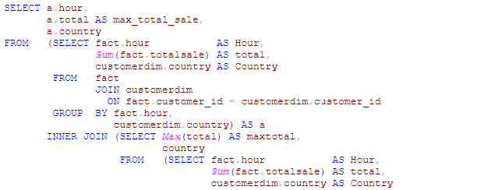



**Create materialized query:**

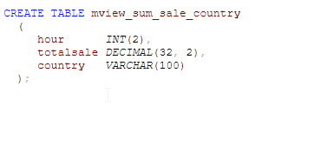

**Insert into materialized query:**

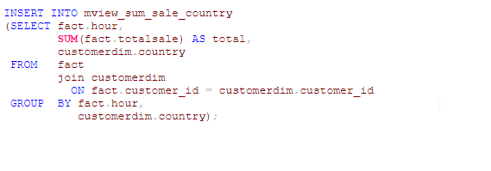

**Query using materialized query**

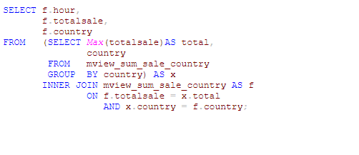

1. **Annual Total Sales Per Product?**

**SQL Query:**

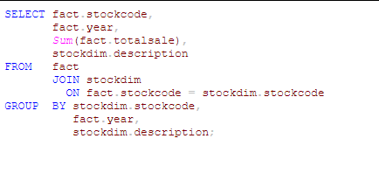

**Create materialized query:**

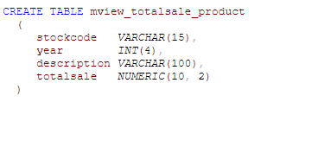

**Insert into materialized query:**

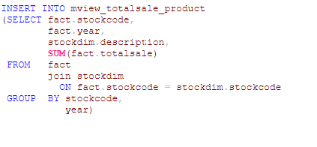

**Query using materialized query**

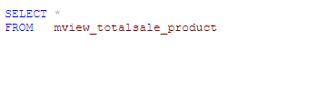

1. **Top Product Per Year**

**SQL Query:**

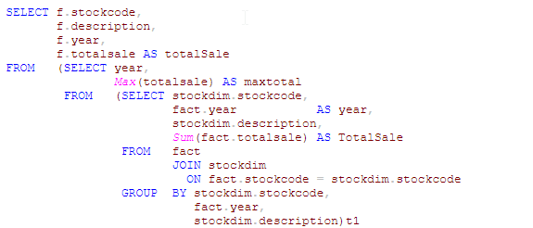

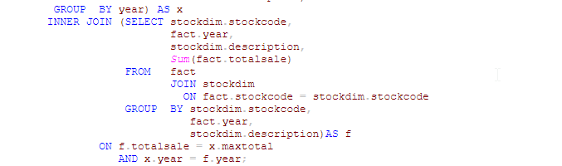

**Query using materialized query:**

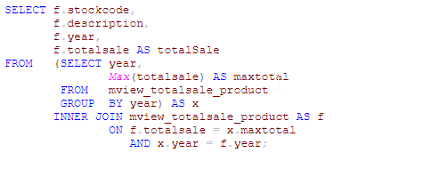

1. **Top Product Per Country**

**SQL Query:**

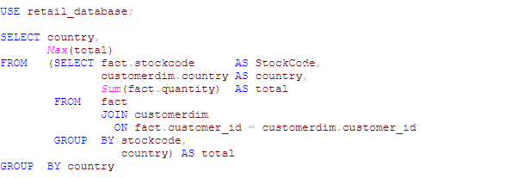

**Create materialized query:**

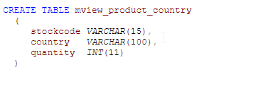

**Insert into materialized query:**

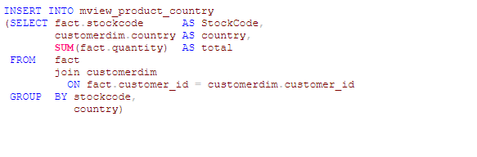

**Query using materialized query:**

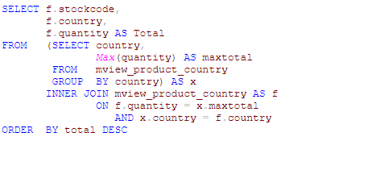

1. **Query 5**

**Create materialized query:**

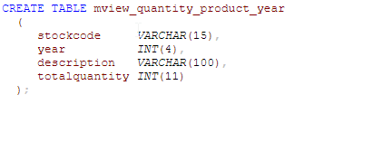

**Insert into materialized query:**

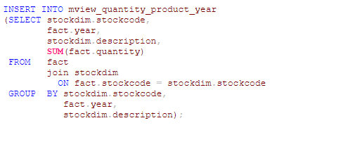

**Query using materialized query:**

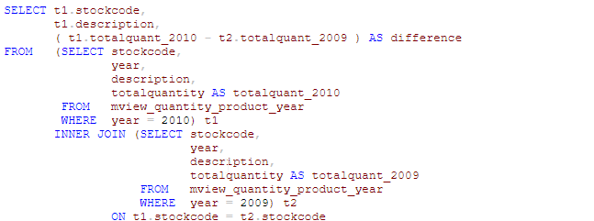



1. **Which customer spends the most per country**

**SQL Query:**

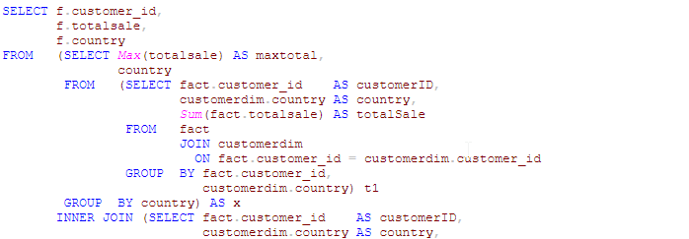

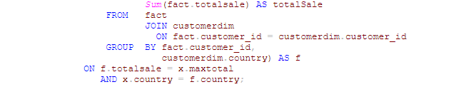

**Create materialized query:**

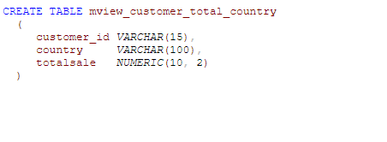

**Insert into materialized query:**

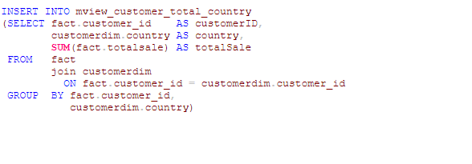

**Query using materialized query:**

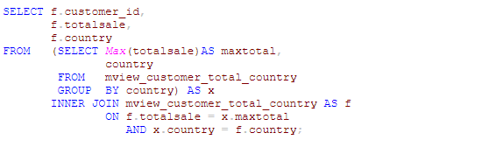

1. **Best-selling month (per country) [2009-2011]**

**SQL Query:**

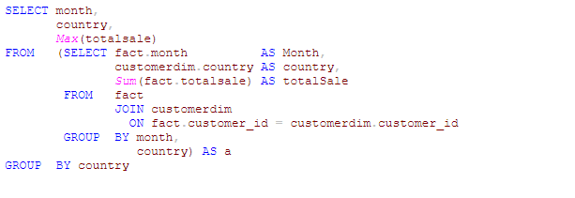

**Create materialized query:**

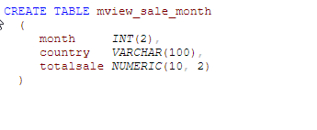

**Insert into materialized query:**

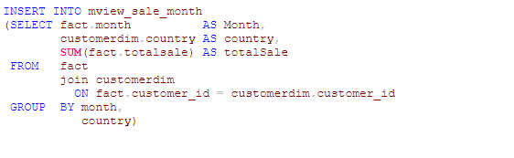

**Query using materialized query:**

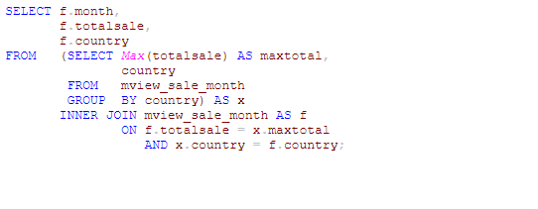

1. **Best-selling product per month [2009-2011]**

**SQL Query:**

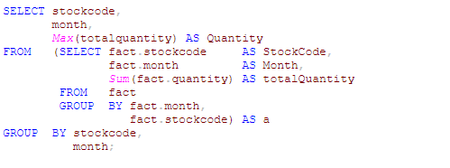

**Create materialized query:**

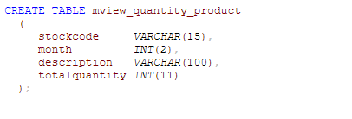

**Insert into materialized query:**

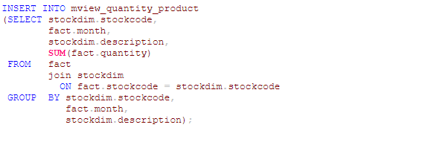

**Query using materialized query:**

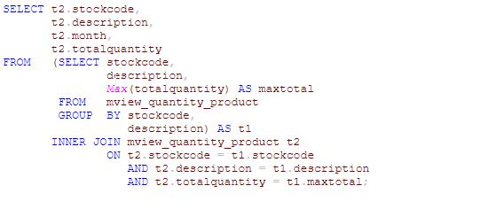

1. **What is the change in total sales per country per year?**

**Create materialized query:**

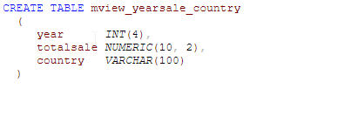

**Insert into materialized query:**

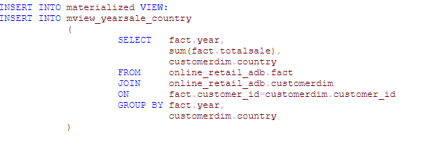

**Query using materialized query**

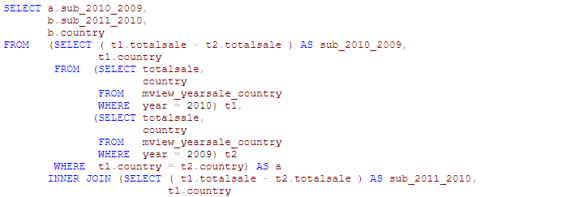

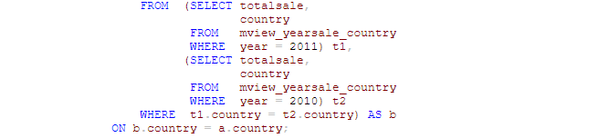

1. **Average spending of customers in a country.**

**SQL Query:**

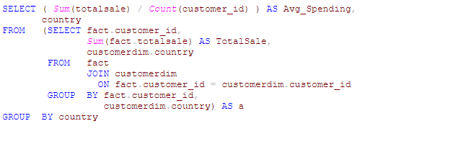

**Query using materialized query:**

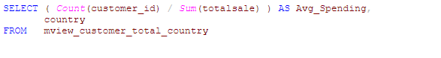

1. **Frequently purchased item per customer.**

**SQL Query:**

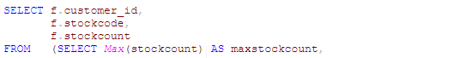

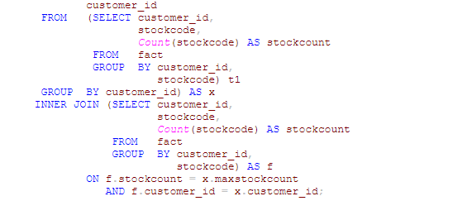

**Appendix B**

**Code for MongoDB**

**ODB Creation**

use odb

mongoimport --db odb --collection retail --type csv --headerline --file Online_Retail_Data.csv

**ADB Creation**

use adb

db.getSiblingDB('odb')['retail'].find( { },

{ CustomerID: 1,

Day: 1,

Month: 1,

Year: 1,

Hour: 1,

Minute: 1,

StockCode: 1,

Quantity: 1,

SubTotal: 1

}

).forEach(function(rec){db.fact.insert(rec) } )

**Creating the FACT Collection (From ODB to ADB)**

db.getSiblingDB('odb')['retail'].find( { },

{ CustomerID: 1,

Day: 1,

Month: 1,

Year: 1,

Hour: 1,

Minute: 1,

StockCode: 1,

Quantity: 1,

SubTotal: 1

}

).forEach(function(rec){db.fact.insert(rec) } )

**Creating the Customer_Dim Collection (From ODB to ADB)**

db.getSiblingDB('odb')['retail'].aggregate(

{"$group" :

{ "_id": {CustomerID:"$CustomerID",

Country:"$Country"}

}

},

{"$match":

{"_id" :

{ "$ne" : null }

}

},

{"$project":

{CustomerID : "$_id.CustomerID",

Country: "$_id.Country", "_id" : 0}

}

).forEach( function (rec) { db.customer_dim.insert(rec) } )

**Creating the Stock_Dim Collection (From ODB to ADB)**

db.stock_dim.createIndex( { "StockCode": 1 } )

db.getSiblingDB('odb')['retail'].aggregate (

[{

$project: {

StockCode: '$StockCode',

Description: '$Description',

Price: '$Price',

desc_lec: {

$strLenCP: '$Description'

}

}

}, {

$group: {

_id: '$StockCode',

Description: {

$first: '$Description'

},

MaxUnitPrice: {

$max: '$Price'

},

max_desc_len: {

$max: '$desc_lec'

}

}

}, {

$project: {

StockCode: '$_id',

Description: 1,

MaxUnitPrice: 1,

_id: 0

}

}]

).forEach( function (rec) {

db.stock_dim.insert(rec)

})

**Creating the Time_Dim Collection (From ODB to ADB)**

db.getSiblingDB('odb')['retail'].find( { },

{ Day: 1,

Month: 1,

Year: 1,

Hour: 1,

Minute: 1

}).forEach(function(rec){db.time_dim_temp.insert(rec) } )

db.time_dim_temp.aggregate (

[{

$group: {

_id: {

Year: "$Year",

Month: "$Month",

Day: "$Day",

Hour: "$Hour",

Minute: "$Minute"

}

}

}

]).forEach( function(rec){ db.time_dim.insert(rec) } )

**Aggregation Queries**

1. **What time of the day is the sale maximum per country?**

db.customer_dim.createIndex( { "CustomerID": 1 } )

db.fact.aggregate(

[{

$lookup: {

from: 'customer_dim',

localField: 'CustomerID',

foreignField: 'CustomerID',

as: 'customer_rec'

}

}, {

$unwind: {

path: '$customer_rec'

}

}, {

$project: {

Hour: 1,

Country: '$customer_rec.Country',

TotalSales: 1,

_id: 0

}

}, {

$group: {

_id: {

Hour: '$Hour',

Country: '$Country'

},

TotalSalePerCountry: {

$sum: '$TotalSales'

}

}

}, {

$project: {

Hour: '$_id.Hour',

Country: '$_id.Country',

TotalSalePerCountry: 1,

rec: '$$ROOT',

_id: 0

}

}, {

$group: {

_id: '$Country',

MaxSalePerHourPerCountry: {

$max: '$TotalSalePerCountry'

},

rec: {

$first: '$rec'

}

}

}, {

$project: {

Country: '$_id',

MaxSalePerHourPerCountry: 1,

Hour: '$rec._id.Hour'

}

}, {

$sort: {

Country: 1

}

}]

)

1. **Annual Total Sales Per Product?**

db.fact.aggregate (

[{

$group: {

_id: {

"Year": "$Year",

"Stock": "$StockCode"

},

TotalAnnualSales: {

$sum: "$TotalSales"

}

}

}, {

$project: {

Year: "$_id.Year",

Stock: "$_id.Stock",

TotalAnnualSales: 1,

_id: 0

}

}, {

$sort: {

Stock: 1,

Year: 1

}

}]

)

1. **Top Product Per Year**

db.fact.aggregate (

[{

$group: {

_id: {

"Year": "$Year",

"StockCode": "$StockCode"

},

TotalAnnualSales: {

$max: {

$sum: "$TotalSales"

}

}

}

}, {

$project: {

TotalAnnualSales: 1,

stock_doc: "$$ROOT"

}

}, {

$group: {

_id: "$_id.Year",

TotalAnnualSales: {

$max: "$TotalAnnualSales"

},

stock_doc: {

$first: "$stock_doc"

}

}

}, {

$project: {

Year: "$_id",

StockCode: "$stock_doc._id.StockCode",

TotalAnnualSales: 1,

_id: 0

}

}, {

$sort: {

Year: 1

}

}]

)

1. **Top Product Per Country**

db.fact.aggregate (

[{

$lookup: {

from: 'customer_dim',

localField: 'CustomerID',

foreignField: 'CustomerID',

as: 'customer_rec'

}

}, {

$unwind: {

path: '$customer_rec'

}

}, {

$group: {

_id: {

StockCode: '$StockCode',

Country: '$customer_rec.Country'

},

TotalSalePsPc: {

$sum: '$TotalSales'

},

all_sales: {

$push: {

sale_rec: '$$ROOT'

}

}

}

}, {

$project: {

StockCode: '$_id.StockCode',

Country: '$_id.Country',

TotalSalePsPc: 1,

rec: '$$ROOT',

_id: 0

}

}, {

$group: {

_id: '$Country',

TotalSalePerStock: {

$max: '$TotalSalePsPc'

},

rec: {

$first: '$rec'

}

}

}, {

$project: {

StockCode: '$rec._id.StockCode',

Country: '$_id',

TotalSalePerStock: 1,

_id: 0

}

}, {

$sort: {

TotalSalePerStock: -1

}

}], {

allowDiskUse: true

}

)

1. **Query 5**

db.fact.aggregate(

[{

$group: {

_id: {

StockCode: '$StockCode',

Year: '$Year'

},

TotalSaleQ: {

$sum: '$Quantity'

},

count: {

$sum: 1

}

}

}, {

$sort: {

_id: 1

}

}, {

$group: {

_id: '$_id.StockCode',

sale_q_per_year: {

$push: {

Year: '$_id.Year',

TotalSaleQ: '$TotalSaleQ',

count: '$count'

}

}

}

}]

).forEach ( function (stkReport) {

var stkCd = stkReport._id;

var prevYr = stkReport.sale_q_per_year[0].Year;

var prevYrAvg = stkReport.sale_q_per_year[0].TotalSaleQ/stkReport.sale_q_per_year[0].count;

for (i = 1; i < stkReport.sale_q_per_year.length; i++) {

var rec = stkReport.sale_q_per_year[i];

var curYrAvg = rec.TotalSaleQ / rec.count;

print("for StockCode:" + stkCd + " previous year: " + prevYr + "'s average: " + prevYrAvg + " and current year " + rec.Year + "'s average is " + curYrAvg);

prevYrAvg = curYrAvg;

}

}

)

1. **Which customer spends the most (per country or overall)**

**Overall:**

db.fact.aggregate (

[{

$project: {

CustomerID: '$CustomerID',

TotalSales: '$TotalSales',

rec: '$$ROOT',

_id: 0

}

}, {

$group: {

_id: '$CustomerID',

TotalSales: {

$sum: '$TotalSales'

},

all_sales: {

$push: {

sale: '$rec'

}

}

}

}, {

$sort: {

TotalSales: -1

}

}, {

$project: {

CustomerID: '$_id',

TotalSales: 1,

rec: '$$ROOT'

}

}, {

$group: {

_id: null,

Max: {

$max: '$TotalSales'

},

rec: {

$first: '$rec'

}

}

}, {

$project: {

Sale: '$Max',

CustomerID: '$rec._id',

_id: 0

}

}], {

allowDiskUse: true

}

)

**Per country:**

db.fact.aggregate (

[{

$lookup: {

from: 'customer_dim',

localField: 'CustomerID',

foreignField: 'CustomerID',

as: 'customer_rec'

}

}, {

$unwind: {

path: '$customer_rec'

}

}, {

$group: {

_id: {

CustomerID: '$CustomerID',

Country: '$customer_rec.Country'

},

TotalSalePerCustomer: {

$sum: '$TotalSales'

},

all_sales: {

$push: {

sale_rec: '$$ROOT'

}

}

}

}, {

$sort: {

TotalSalePerCustomer: -1

}

}, {

$project: {

CustomerID: '$_id.CustomerID',

Country: '$_id.Country',

TotalSalePerCustomer: 1,

_id: 0

}

}, {

$group: {

_id: {

CustomerID: '$CustomerID',

Country: '$Country'

},

TotalSalePerCustomer: {

$max: '$TotalSalePerCustomer'

}

}

}, {

$sort: {

TotalSalePerCustomer: -1

}

}, {

$project: {

CustomerID: '$_id.CustomerID',

Country: '$_id.Country',

TotalSalePerCustomer: 1,

_id: 0,

}

}], {

allowDiskUse: true

}

)

1. **Best-selling month (per country) [2009-2011]**

db.fact.aggregate (

[{

$lookup: {

from: 'customer_dim',

localField: 'CustomerID',

foreignField: 'CustomerID',

as: 'customer_rec'

}

}, {

$unwind: {

path: '$customer_rec'

}

}, {

$project: {

Month: 1,

Country: '$customer_rec.Country',

TotalSales: 1,

_id: 0

}

}, {

$group: {

_id: {

Month: '$Month',

Country: '$Country'

},

TotalSalePerCountry: {

$sum: '$TotalSales'

}

}

}, {

$project: {

Month: '$_id.Month',

Country: '$_id.Country',

TotalSalePerCountry: 1,

rec: '$$ROOT',

_id: 0

}

}, {

$group: {

_id: '$Country',

MaxSalePerHourPerCountry: {

$max: '$TotalSalePerCountry'

},

rec: {

$first: '$rec'

}

}

}, {

$project: {

Country: '$_id',

MaxSalePerHourPerCountry: 1,

Month: '$rec._id.Month'

}

}, {

$sort: {

Country: 1

}

}], {

allowDiskUse: true

}

)

1. **Best-selling product per month [2009-2011]**

db.fact.aggregate(

[{

$lookup: {

from: 'stock_dim',

localField: 'StockCode',

foreignField: 'StockCode',

as: 'StockCode'

}

}, {

$group: {

_id: '$Month',

max: {

$max: '$Quantity'

},

StockCode: {

$first: '$StockCode'

}

}

}, {

$unwind: {

path: '$StockCode'

}

}, {

$project: {

Month: '$_id',

StockCode: '$StockCode.StockCode',

StockDescription: '$StockCode.Description',

Quantity: '$max',

_id: 0

}

}, {

$sort: {

Month: 1

}

}], {

allowDiskUse: true

}

)

1. **What is the change in total sales per country per year?**

db.fact.aggregate(

[{

$lookup: {

from: 'customer_dim',

localField: 'CustomerID',

foreignField: 'CustomerID',

as: 'customer_rec'

}

}, {

$replaceRoot: {

newRoot: {

$mergeObjects: [{

$arrayElemAt: [ '$customer_rec', 0 ]

},

'$$ROOT'

]

}

}

}, {

$group: {

_id: {

Country: '$Country',

Year: '$Year'

},

TotalSalePerCountry: {

$sum: '$TotalSales'

}

}

}, {

$sort: {

_id: 1

}

}, {

$group: {

_id: '$_id.Country',

all_recs: {

$push: {

Year: '$_id.Year',

TotalSaleInYear: '$TotalSalePerCountry'

}

}

}

}], {

allowDiskUse: true

}

).forEach(

function(doc) {

if (doc.all_recs.length > 1) {

var prevYear = doc.all_recs[0].Year;

var prevYearSale = doc.all_recs[0].TotalSaleInYear;

for (i = 1; i < doc.all_recs.length; i++) {var curYear = doc.all_recs[i].Year;

var curYearSale = doc.all_recs[i].TotalSaleInYear;

var diff = curYearSale - prevYearSale;

print("For " + doc._id + " sale increase between years " + curYear + " and " + prevYear + " is: " + diff);

prevYearSale = curYearSale;

prevYear = curYear;

}

} else if (doc.all_recs.length == 1) {

print("For " + doc._id + " sale record available for only year: " + doc.all_recs[0].Year + " and sale was: " + doc.all_recs[0].TotalSaleInYear);

}

}

)

1. **Average spending of customers in a country.**

db.fact.aggregate(

[{

$lookup: {

from: 'customer_dim',

localField: 'CustomerID',

foreignField: 'CustomerID',

as: 'customer_rec'

}

}, {

$unwind: {

path: '$customer_rec'

}

}, {

$project: {

rec: '$$ROOT'

}

}, {

$group: {

_id: '$rec.customer_rec.Country',

AvgSpending: {

$avg: '$rec.TotalSales'

},

rec: {

$first: '$rec'

}

}

}, {

$project: {

Country: '$_id',

AvgSpending: 1,

_id: 0

}

}, {

$sort: {

AvgSpending: -1

}

}], {

allowDiskUse: true

}

)

1. **Frequently purchased item per customer.**

db.fact.aggregate(

[{

$group: {

_id: {

CustomerID: '$CustomerID',

StockCode: '$StockCode'

},

count: {

$sum: 1

}

}

}, {

$project: {

CustomerID: '$_id.CustomerID',

StockCode: '$_id.StockCode',

count: 1

}

}, {

$sort: {

count: -1,

CustomerID: 1

}

}]

)

**APPENDIX C**

**Neo4j Codes**

1. **Query for Importing into and Creating ODB**

a.

:auto USING PERIODIC COMMIT 1000 LOAD CSV WITH HEADERS FROM 'file:///Cleaned_2009_2010.csv' AS test CREATE (:ODB {Invoice: test.Invoice, StockCode: test.StockCode, Description: test.Description, Quantity: toInteger(test.Quantity), InvoiceDate: test.InvoiceDate, InvoiceTime: test.InvoiceTime, Price: toFloat(test.Price), CustomerID: test.CustomerID, Country:test.Country, SubTotal: toFloat(test.SubTotal)})

b.

:auto USING PERIODIC COMMIT 1000 LOAD CSV WITH HEADERS FROM 'file:///Cleaned_2010_2011.csv' AS test CREATE (:ODB {Invoice: test.Invoice, StockCode: test.StockCode, Description: test.Description, Quantity: toInteger(test.Quantity), InvoiceDate: test.InvoiceDate, InvoiceTime: test.InvoiceTime, Price: toFloat(test.Price), CustomerID: test.CustomerID, Country:test.Country, SubTotal: toFloat(test.SubTotal)})

1. **Query for Cleaning ODB**

a.

MATCH(m:ODB)

WITH [item in split(m.InvoiceDate, "/") | toInteger(item)] AS dateComponents, m AS m

SET m.InvoiceDate = date({day: dateComponents[1], month: dateComponents[0], year: dateComponents[2]})

b.

CALL apoc.periodic.iterate(

"MATCH(n:ODB) RETURN n",

"SET n.InvoiceTime = time(n.InvoiceTime)",

{batchSize:100000})

1. **Query for Creating the Tables**
2. **FACT**

CALL apoc.periodic.iterate(

"MATCH(n:ODB) RETURN n",

"CREATE(:FACT{CustomerID: n.CustomerID, Year: n.InvoiceDate.year, Month: n.InvoiceDate.month, Day: n.InvoiceDate.day, Hour: n.InvoiceTime.hour, Minute: n.InvoiceTime.minute, StockCode: n.StockCode, Quantity: n.Quantity, TotalSales: n.SubTotal, TimeID:datetime({Year: n.InvoiceDate.year, Month: n.InvoiceDate.month, Day: n.InvoiceDate.day, Hour: n.InvoiceTime.hour, Minute: n.InvoiceTime.minute})})",

{batchSize:10000})

1. **CUSTOMERDIM**

CALL apoc.periodic.iterate(

"MATCH(n:ODB)

RETURN n.CustomerID as CustomerID, n.Country as Country

UNION

MATCH(n:ODB)

RETURN n.CustomerID as CustomerID, n.Country as Country",

"CREATE(:CUSTOMERDIM{ CustomerID: CustomerID , Country: Country})",

{batchSize:10000})

1. **STOCKDIM**

CALL apoc.periodic.iterate(

"MATCH (n:ODB) RETURN n.StockCode as StockCode, max(n.Description) as Description, max(n.Price) as Price",

"CREATE(:STOCKDIM{StockCode: StockCode, Description: Description, Price: Price})",

{batchSize:10000})

1. **TIMEDIM**

CALL apoc.periodic.iterate(

"MATCH(n:ODB)

RETURN n.InvoiceDate.year as Year, n.InvoiceDate.month as Month, n.InvoiceDate.day as Day,n.InvoiceTime.hour as Hour, n.InvoiceTime.minute as Minute

UNION

MATCH(n:ODB)

RETURN n.InvoiceDate.year as Year, n.InvoiceDate.month as Month, n.InvoiceDate.day as Day,n.InvoiceTime.hour as Hour, n.InvoiceTime.minute as Minute",

"CREATE(:TIMEDIM{ Year: Year , Month: Month, Day: Day, Hour: Hour, Minute: Minute, TimeID:datetime({Year: Year , Month: Month, Day: Day, Hour: Hour, Minute: Minute})})",

{batchSize:10000})

1. **Query for Creating the Relationship between Tables**
2. **Creating Relationship between FACT and CUSTOMERDIM**

CALL apoc.periodic.iterate(

"MATCH(n:FACT),(m:CUSTOMERDIM)

WHERE n.CustomerID=m.CustomerID

RETURN n,m",

"CREATE (n)-[:IS_CUSTOMER]->(m)",

{batchSize:100000})

1. **Creating Relationship between FACT and STOCKDIM**

CALL apoc.periodic.iterate(

"MATCH(n:FACT),(m:STOCKDIM)

WHERE n.StockCode=m.StockCode

RETURN n,m",

"CREATE (n)-[:IS_STOCK]->(m)",

{batchSize:100000})

1. **Creating Relationship between FACT and TIMEDIM**

CALL apoc.periodic.iterate(

"MATCH(n:FACT),(m:TIMEDIM)

WHERE n.TimeID=m.TimeID

RETURN n,m",

"CREATE (n)-[:IS_TIME]->(m)",

{batchSize:100000})

1. **Aggregation Queries**
2. **What time of the day (which hour of the day) is the sale maximum per country?**

CALL{

MATCH(c:CUSTOMERDIM)<-[r1:IS_CUSTOMER]-(f:FACT)-[r2:IS_STOCK]->(s:STOCKDIM)

WITH [SUM(f.TotalSales), time({Hour:f.Hour, Minute:f.Minute}), c.Country] AS Top_Prod

RETURN MAX(Top_Prod[0]) AS TotalSales, Top_Prod[1] AS Time, Top_Prod[2] AS Country

ORDER BY TotalSales DESC, Country

}

RETURN Country, collect(Time)[0] AS Time, ROUND(MAX(TotalSales)) AS TotalSales

ORDER BY Country

1. **What is the annual TotalSales per product?**

MATCH(s:STOCKDIM)<-[r1:IS_STOCK]-(f:FACT)

RETURN s.Description AS Description, SUM(ROUND(f.TotalSales)) AS Annual_Sales, f.Year AS Year

ORDER BY Description, Year

1. **What is the top product per year?**

CALL{

MATCH(s:STOCKDIM)<-[r1:IS_STOCK]-(f:FACT)

WITH [s.Description, SUM(ROUND(f.TotalSales)), f.Year] AS INFO

RETURN INFO[0] AS Description, INFO[1] AS Annual_Sales, INFO[2] AS Year

ORDER BY Annual_Sales DESC, Year

}

RETURN MAX(Annual_Sales), collect(Description)[0], Year

ORDER BY Year

1. **What is the top product per country?**

CALL{

MATCH(c:CUSTOMERDIM)<-[r1:IS_CUSTOMER]-(f:FACT)-[r2:IS_STOCK]->(s:STOCKDIM)

WITH [SUM(f.Quantity), s.Description, c.Country] AS Top_Prod

RETURN MAX(Top_Prod[0]) AS Quantity, Top_Prod[1] AS Description, Top_Prod[2] AS Country

ORDER BY Quantity DESC, Country ASC

}

RETURN MAX(Quantity), collect(Description)[0], Country

ORDER BY Country

1. **Which item is sold below a certain threshold value? Or, what are the under-performed products based on the average sales last year?**
2. **Which customer spends the most per country?**

CALL{

MATCH(f:FACT)-[r1:IS_CUSTOMER]->(c:CUSTOMERDIM)

WITH [SUM(f.TotalSales), f.CustomerID, c.Country] AS Sales_per_Customer, c

RETURN MAX(Sales_per_Customer[0]) AS Total_Sale, Sales_per_Customer[1] AS CustomerID, Sales_per_Customer[2] AS Country, c, Sales_per_Customer

ORDER BY Total_Sale DESC, Country

}

RETURN MAX(Total_Sale), collect(CustomerID)[0], Country

ORDER BY Country

1. **What is the best-selling month per country? (Given the year range, 2009-2011)**

CALL{

MATCH(c:CUSTOMERDIM)<-[r1:IS_CUSTOMER]-(f:FACT)-[r2:IS_STOCK]->(s:STOCKDIM)

WITH [SUM(f.Quantity), f.Month, c.Country] AS Top_Prod

RETURN MAX(Top_Prod[0]) AS Quantity, Top_Prod[1] AS Month, Top_Prod[2] AS Country

ORDER BY Quantity DESC, Country

}

RETURN Country, ["January", "February", "March", "April", "May", "June", "July", "August", "September", "October", "November", "December"][collect(Month)[0]-1] AS Month, MAX(Quantity) AS Quantity

ORDER BY Country

1. **What is the best-selling product per month? (Given the year range, 2009-2011)**

CALL{

MATCH(c:CUSTOMERDIM)<-[r1:IS_CUSTOMER]-(f:FACT)-[r2:IS_STOCK]->(s:STOCKDIM)

WITH [SUM(f.Quantity), s.Description, f.Month] AS INFO

RETURN MAX(INFO[0]) AS Quantity, INFO[1] AS Description, INFO[2] AS Months

ORDER BY Quantity DESC, Months

}

RETURN Months AS SrNo, ["January", "February", "March", "April", "May", "June", "July", "August", "September", "October", "November", "December"][Months-1] AS Month, collect(Description)[0] AS Description, MAX(Quantity) AS Quantity

ORDER BY SrNo

1. **What is the change in TotalSales per country per year (Trend of Sales)?**
2. **What is the average spending of a customer per country? (TotalSales/Number of customers)**

MATCH(f:FACT)-[r1:IS_CUSTOMER]->(c:CUSTOMERDIM)

WITH [SUM(f.TotalSales),f.CustomerID] AS Sales_per_Customer, c

RETURN AVG(Sales_per_Customer[0]) AS Average_Spending_Per_Customer, c.Country AS Country

1. **What is the frequently purchased item per customer?**

CALL{

MATCH(f:FACT)-[r1:IS_STOCK]-(s:STOCKDIM)

WITH [COUNT(f.StockCode), s.Description, f.CustomerID] AS INFO

RETURN MAX(INFO[0]) AS Frequency, INFO[1] AS Description, INFO[2] AS CustomerID

ORDER BY Frequency DESC, CustomerID

}

RETURN MAX(Frequency) AS Frequency, collect(Description)[0] AS Description, CustomerID

ORDER BY CustomerID

1. **Order of Execution**

* Save the .CSV files folder into the import folder of the database
* Run ODB creation query
* Run the ODB cleaning query
* Create the ADB
* Create the relation between the ADB tables